# Supplementary Figures and Tables

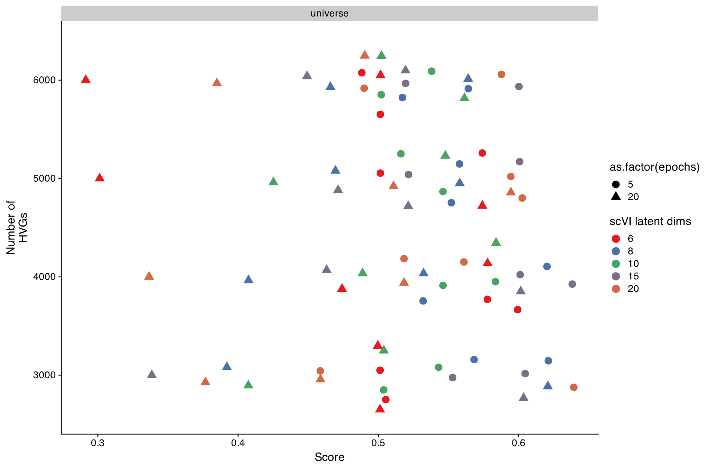

Supplemental Figure 1: scPOP based performance scoring (higher is better) across different numbers of highly variable genes, epochs of scANVI used, and number of outputted latent dimensions.

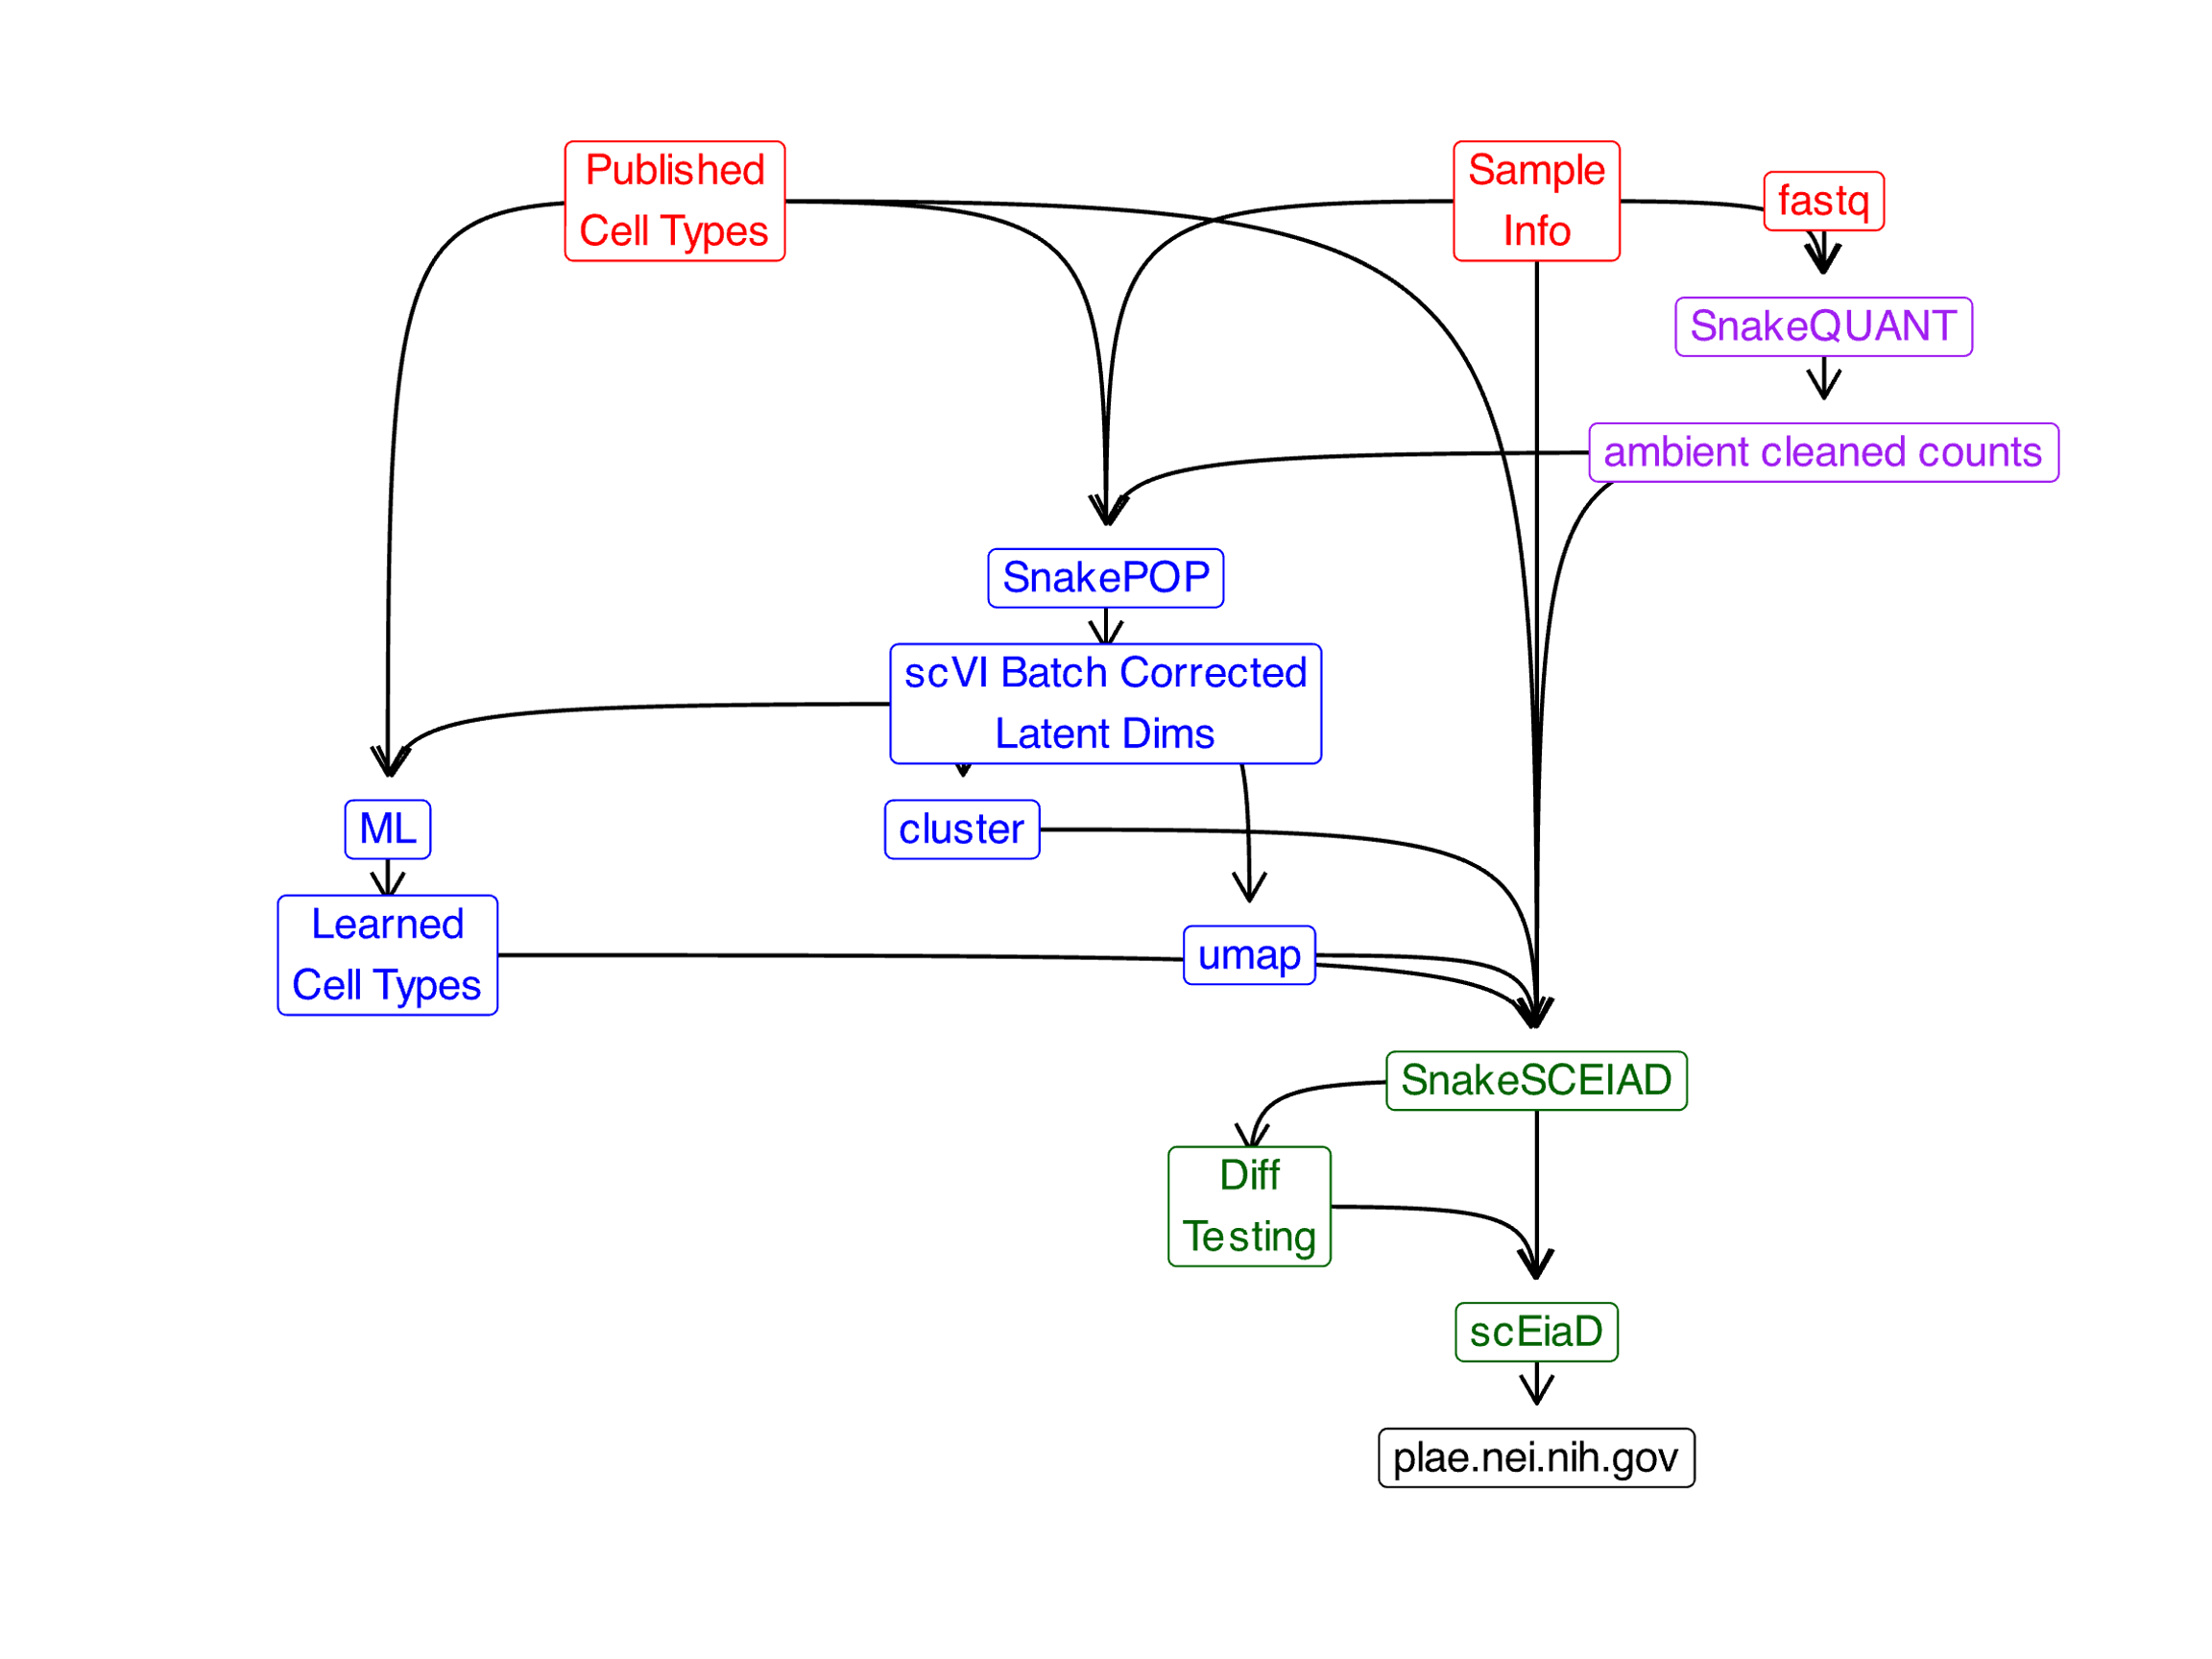

Supplemental Figure 2: Data flow overview from published cell types, sample information, raw fastq counts to produce the sqlite database used in plae.nei.nih.gov

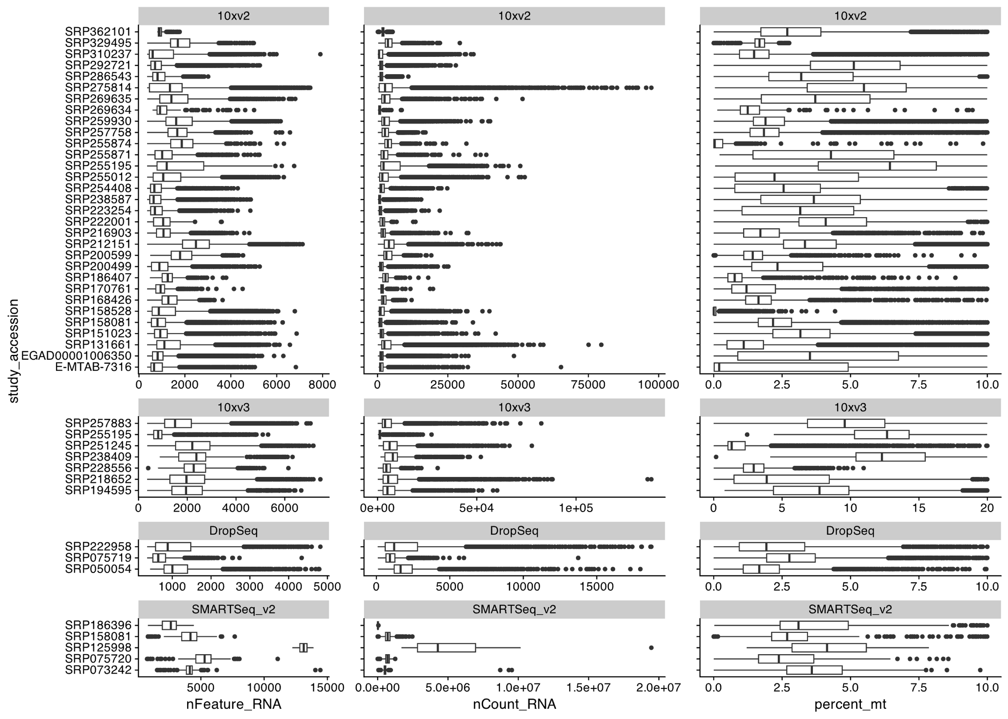

Supplemental Figure 3: Study level box plot showing unique genes identified, total gene counts, and percent mitochondrial reads.

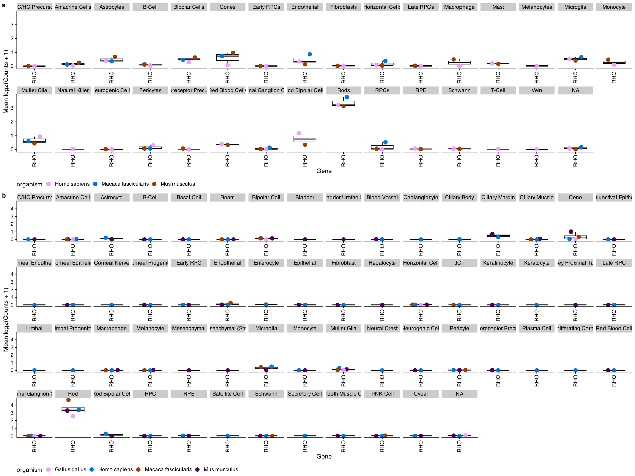

Supplemental Figure 4: DecontX in silico ambient RNA contamination tool substantially removes Rhodopsin expression in non-rod cells while retaining high expression rods. First shown (a) is Rhodopsin expression across the scEiaD v0 dataset, without DecontX optimization. Note Rhodopsin expression is noticeable in many cell types beyond the rods. Next (b) is the scEiaD v1 dataset with DecontX optimization. Rhodopsin is nearly exclusively expressed in labelled rod cells. Despite the computational ambient RNA removal, Rhodopsin expression remains high in the Rods.

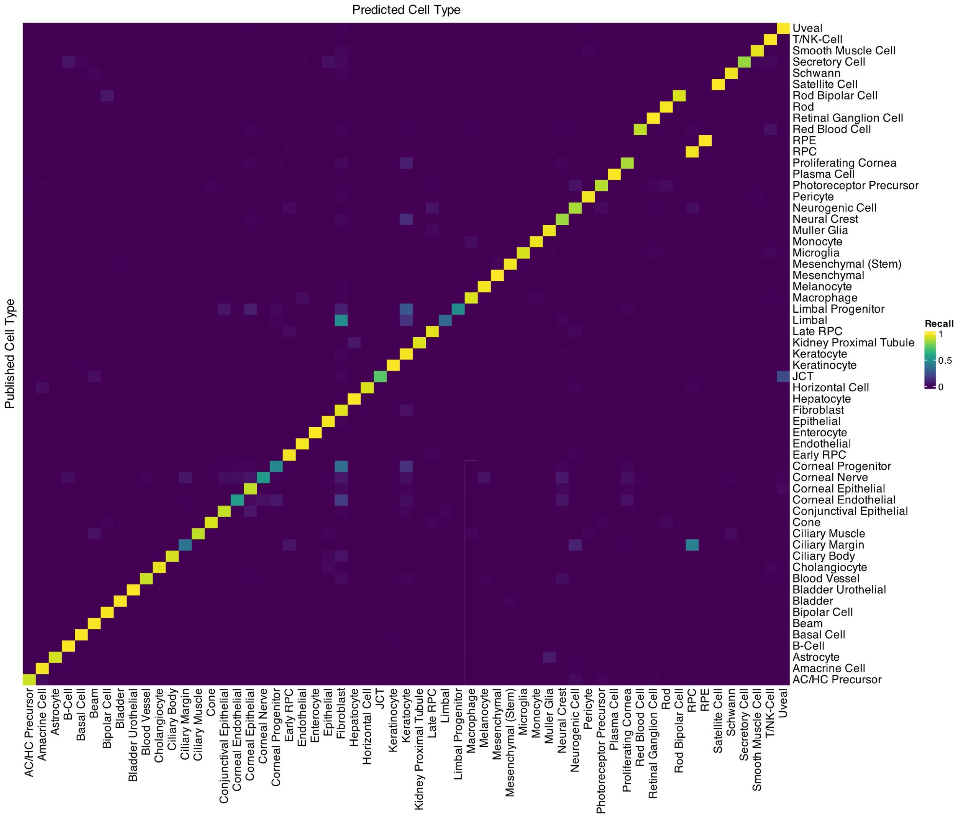

Supplemental Figure 5: Confusion matrix of cell type label consistency between predicted cell types (columns) and published cell types (rows).

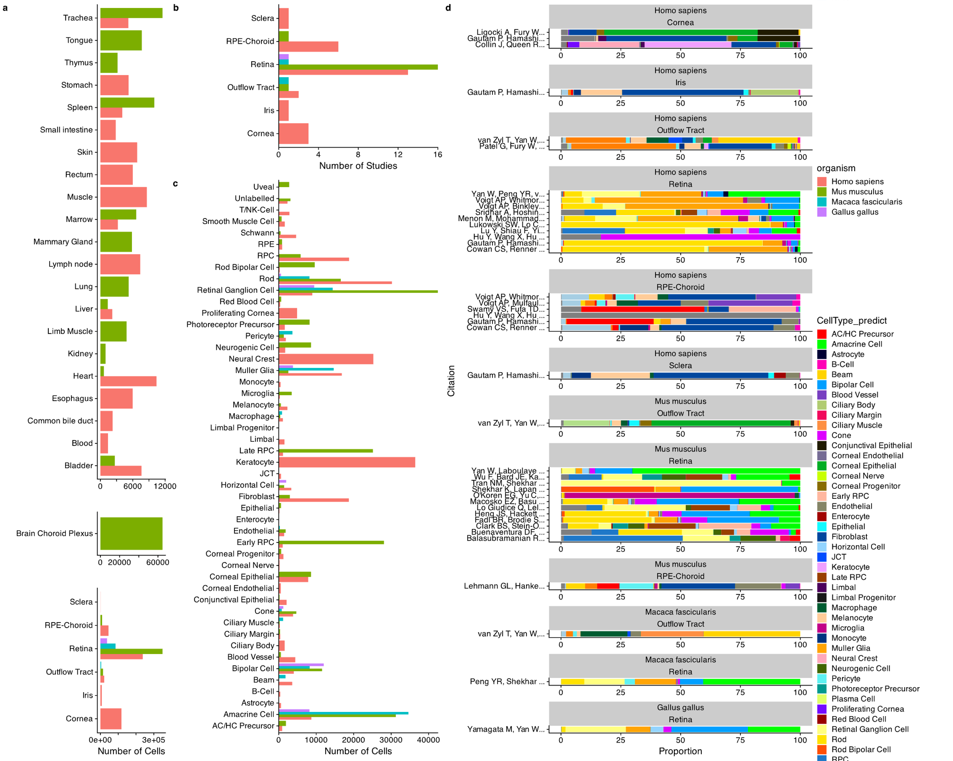

Supplemental Figure 6: Distribution of tissues and cell types in scEiaD. A. tabulation of the number of cells present across 6 ocular and 23 non-ocular tissues, B. Number of studies for each ocular tissue. C. Number of cells present across 53 curated ocular-derived cell types. D. Proportion of cell types (predicted) across each study (split by species and tissue).

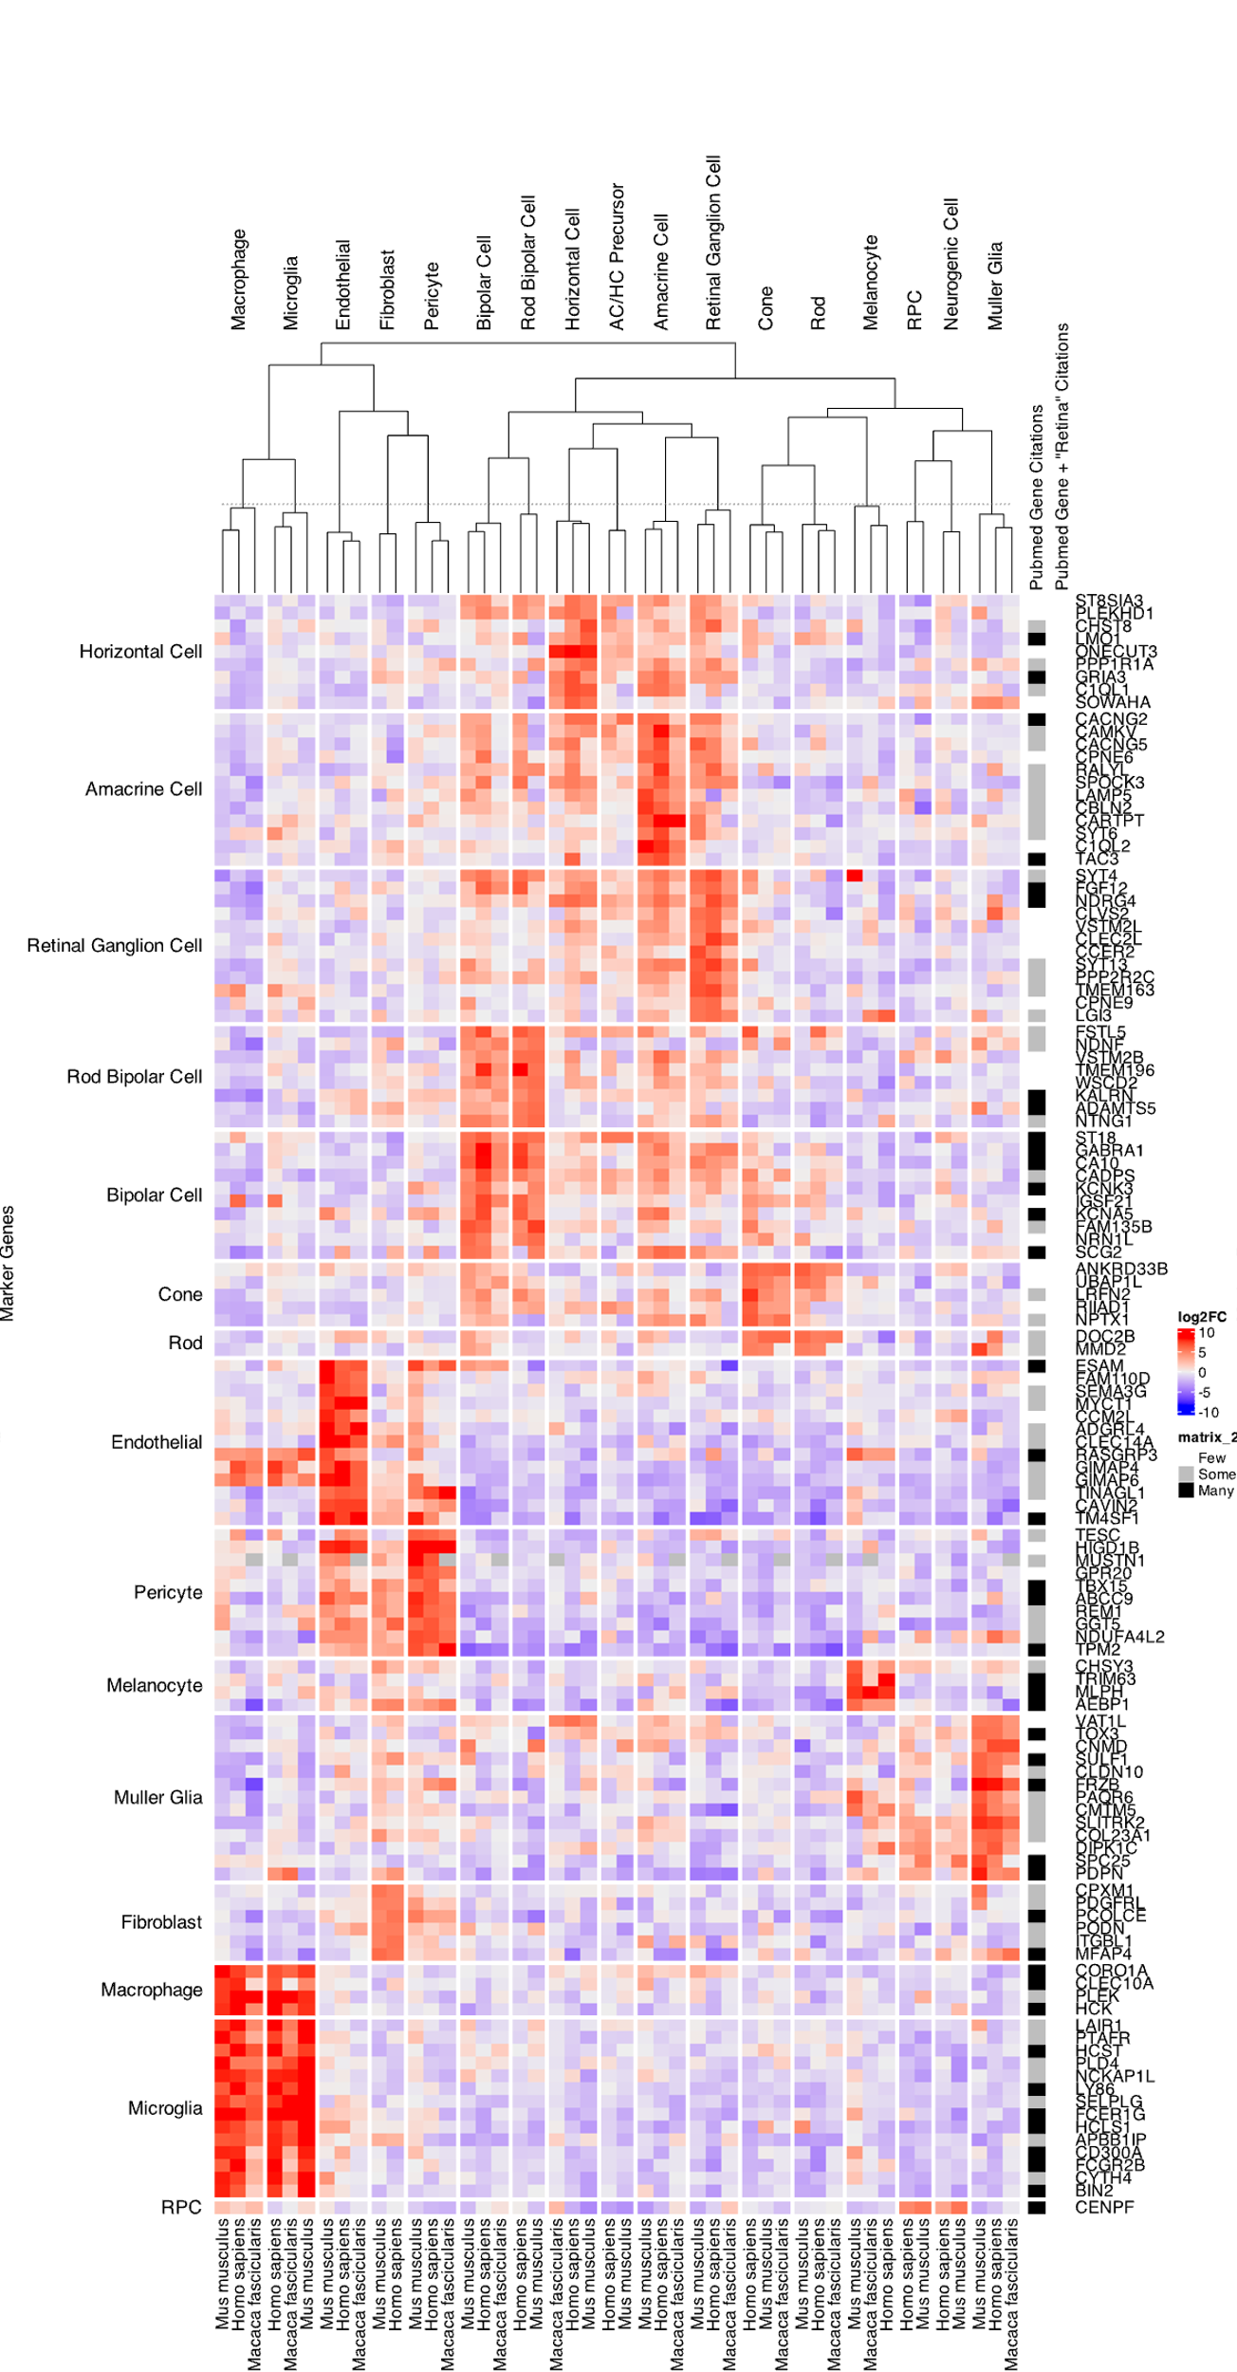

Supplemental Figure 7: Well supported genes with a mean log2FC > 5 and zero pubmed citation hits for [gene] AND Retina search.

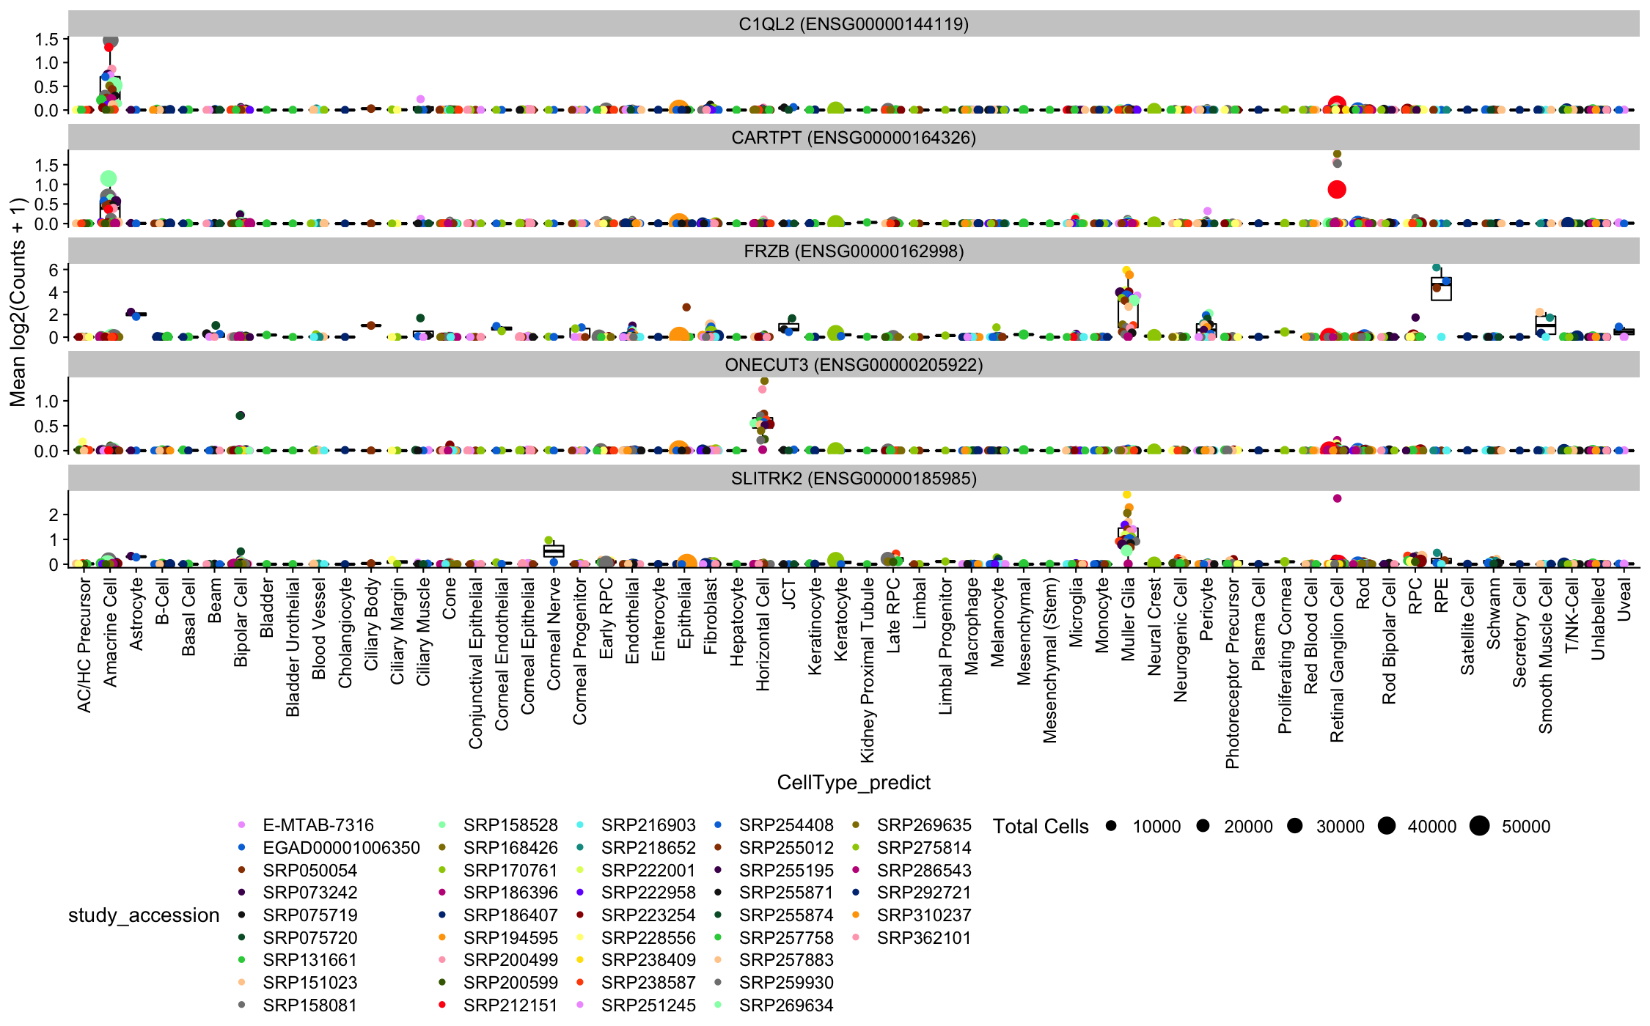

Supplemental Figure 8: Five hand-selected genes selected from Supplementary Figure 3 as having fairly unique expression to a celltype while having few pubmed citations. Plotted as expression/boxplots to confirm specificity at the study level.

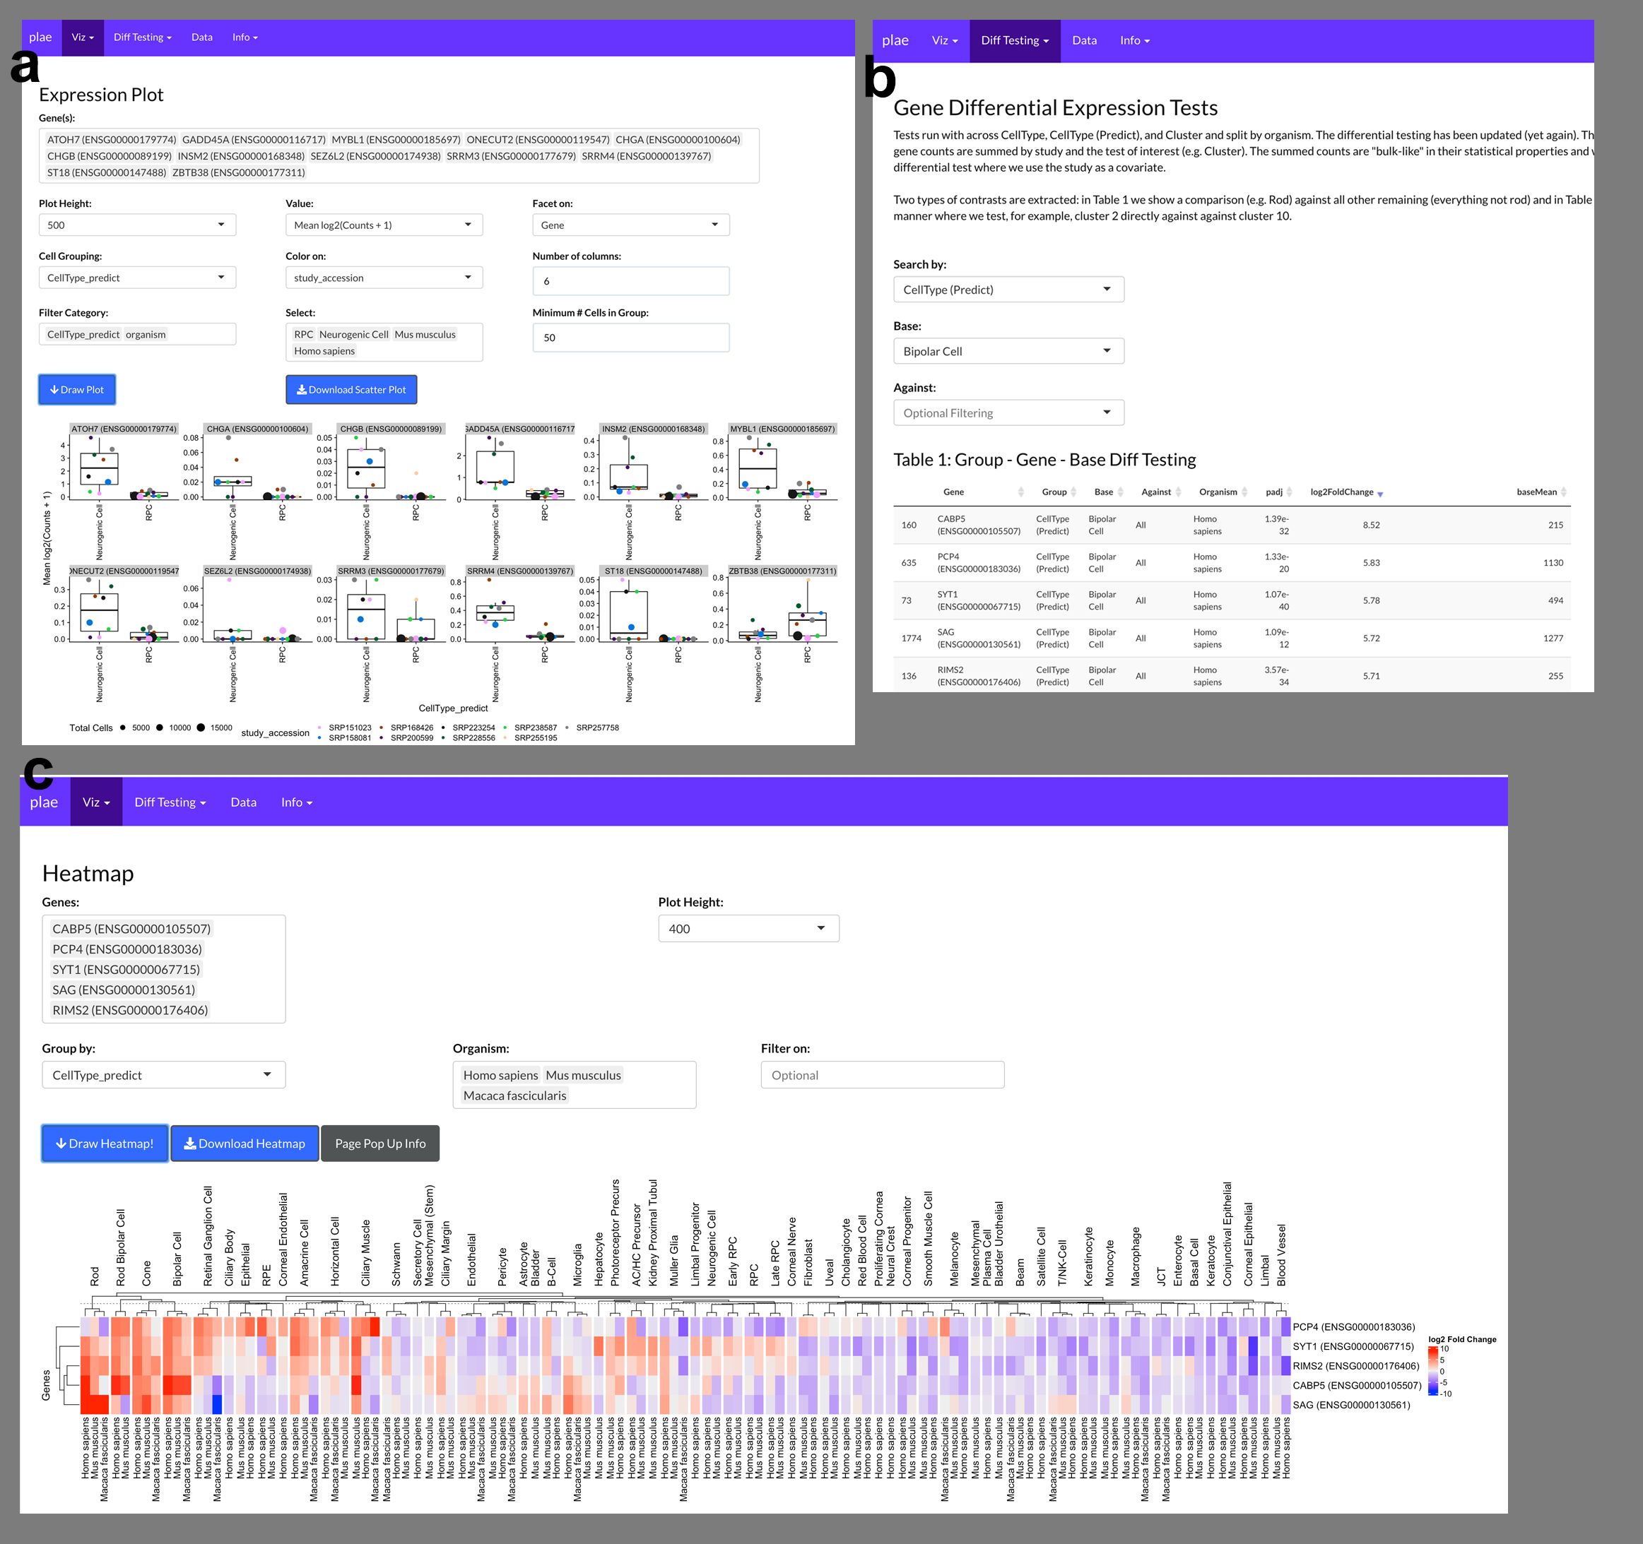

Supplemental Figure 9: a. Recreation of Figure 4 directly in the plae.nei.nih.gov web app. b. Identify potential bipolar cell markers with the precomputed differential testing and in c. visualize the top five genes with a Heatmap.

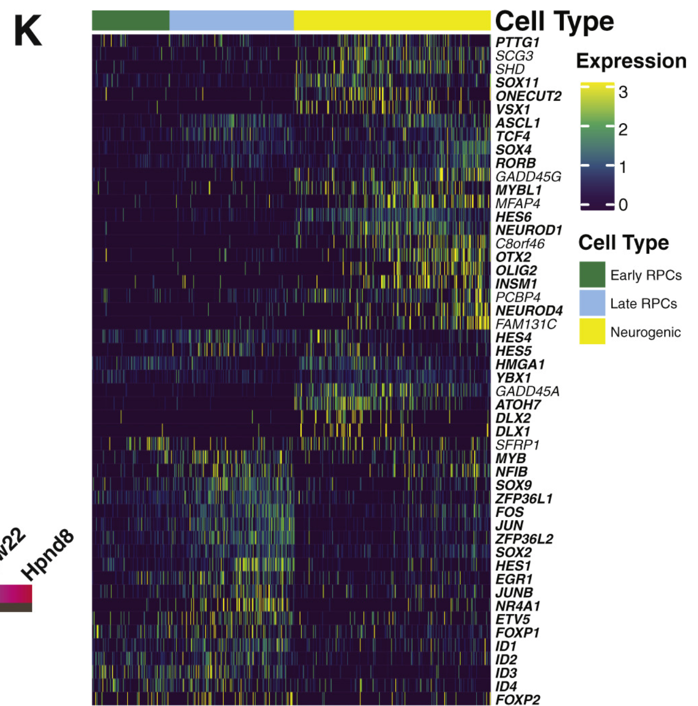

Supplemental Figure 10: Supplemental figure 2K from Lu et al showing their candidate RPC / Neurogenic differentially expressed genes

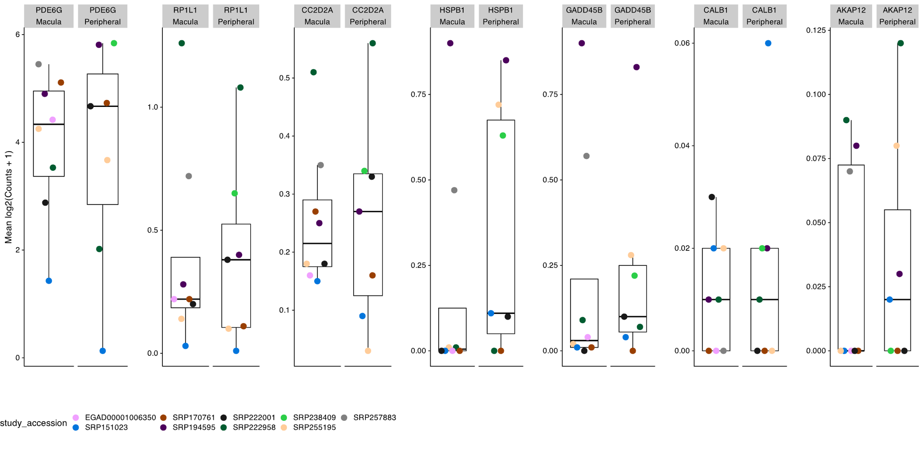

Supplemental Figure 11: Human cone fovea - peripheral differentially expressed genes are not differentially expressed in human rods.

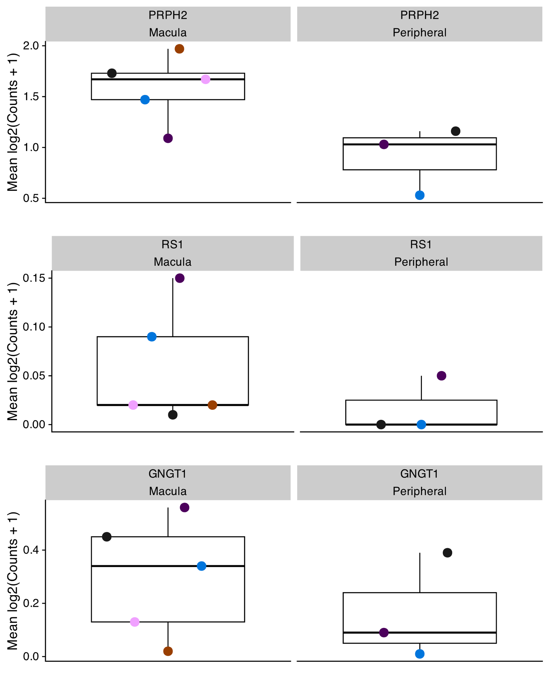

Supplemental Figure 12: Genes identified by Peng et al. and Yan et al. as macula / peripheral differentially expressed in cones.

| organism | CellType | CellType_predict | Count | Ratio |
| --- | --- | --- | --- | --- |
| Gallus gallus | Amacrine Cell | Amacrine Cell | 6,483 | 0.98750952 |
| Gallus gallus | Bipolar Cell | Bipolar Cell | 10,681 | 0.99636194 |
| Gallus gallus | Cone | Cone | 1,112 | 0.98407080 |
| Gallus gallus | Horizontal Cell | Amacrine Cell | 30 | 0.01723148 |
| Gallus gallus | Horizontal Cell | Horizontal Cell | 1,694 | 0.97300402 |
| Gallus gallus | Muller Glia | Muller Glia | 3,033 | 0.99835418 |
| Gallus gallus | Retinal Ganglion Cell | Retinal Ganglion Cell | 6,880 | 0.99811403 |
| Gallus gallus | Rod | Bipolar Cell | 26 | 0.04227642 |
| Gallus gallus | Rod | Cone | 14 | 0.02276423 |
| Gallus gallus | Rod | Rod | 575 | 0.93495935 |
| Homo sapiens | AC/HC Precursor | AC/HC Precursor | 1,307 | 0.91462561 |
| Homo sapiens | AC/HC Precursor | Amacrine Cell | 49 | 0.03428971 |
| Homo sapiens | AC/HC Precursor | Neurogenic Cell | 35 | 0.02449265 |
| Homo sapiens | AC/HC Precursor | Photoreceptor Precursor | 15 | 0.01049685 |
| Homo sapiens | Amacrine Cell | Amacrine Cell | 7,776 | 0.98517674 |
| Homo sapiens | Astrocyte | Astrocyte | 287 | 0.95348837 |
| Homo sapiens | Astrocyte | Muller Glia | 14 | 0.04651163 |
| Homo sapiens | B-Cell | B-Cell | 7,970 | 0.98589807 |
| Homo sapiens | Basal Cell | Basal Cell | 736 | 0.99459459 |
| Homo sapiens | Beam | Beam | 3,052 | 0.99348958 |
| Homo sapiens | Bipolar Cell | Bipolar Cell | 3,790 | 0.96807152 |
| Homo sapiens | Bipolar Cell | Muller Glia | 48 | 0.01226054 |
| Homo sapiens | Blood Vessel | Blood Vessel | 3,773 | 0.91733528 |
| Homo sapiens | Blood Vessel | Fibroblast | 108 | 0.02625821 |
| Homo sapiens | Blood Vessel | Keratocyte | 44 | 0.01069779 |
| Homo sapiens | Blood Vessel | Neural Crest | 112 | 0.02723073 |
| Homo sapiens | Cholangiocyte | Cholangiocyte | 235 | 0.96311475 |
| Homo sapiens | Cholangiocyte | Epithelial | 5 | 0.02049180 |
| Homo sapiens | Cholangiocyte | T/NK-Cell | 3 | 0.01229508 |
| Homo sapiens | Ciliary Body | Ciliary Body | 1,378 | 0.93487110 |
| Homo sapiens | Ciliary Body | Epithelial | 23 | 0.01560380 |
| Homo sapiens | Ciliary Body | Fibroblast | 69 | 0.04681140 |
| Homo sapiens | Ciliary Margin | B-Cell | 4 | 0.01104972 |
| Homo sapiens | Ciliary Margin | Ciliary Margin | 324 | 0.89502762 |
| Homo sapiens | Ciliary Margin | Corneal Epithelial | 11 | 0.03038674 |
| Homo sapiens | Ciliary Margin | Corneal Nerve | 5 | 0.01381215 |
| Homo sapiens | Ciliary Margin | Proliferating Cornea | 9 | 0.02486188 |
| Homo sapiens | Ciliary Muscle | Beam | 37 | 0.22155689 |
| Homo sapiens | Ciliary Muscle | Ciliary Muscle | 88 | 0.52694611 |
| Homo sapiens | Ciliary Muscle | Corneal Epithelial | 3 | 0.01796407 |
| Homo sapiens | Ciliary Muscle | Macrophage | 2 | 0.01197605 |
| Homo sapiens | Ciliary Muscle | Schwann | 33 | 0.19760479 |
| Homo sapiens | Cone | Cone | 3,737 | 0.97343058 |
| Homo sapiens | Conjunctival Epithelial | Conjunctival Epithelial | 824 | 0.91150442 |
| Homo sapiens | Conjunctival Epithelial | Corneal Epithelial | 47 | 0.05199115 |
| Homo sapiens | Corneal Endothelial | Corneal Endothelial | 490 | 0.55872292 |
| Homo sapiens | Corneal Endothelial | Corneal Epithelial | 18 | 0.02052452 |
| Homo sapiens | Corneal Endothelial | Corneal Nerve | 33 | 0.03762828 |
| Homo sapiens | Corneal Endothelial | Corneal Progenitor | 56 | 0.06385405 |
| Homo sapiens | Corneal Endothelial | Fibroblast | 159 | 0.18129989 |
| Homo sapiens | Corneal Endothelial | Keratocyte | 25 | 0.02850627 |
| Homo sapiens | Corneal Endothelial | Neural Crest | 45 | 0.05131129 |
| Homo sapiens | Corneal Endothelial | Proliferating Cornea | 39 | 0.04446978 |
| Homo sapiens | Corneal Epithelial | Corneal Epithelial | 1,689 | 0.93057851 |
| Homo sapiens | Corneal Epithelial | Fibroblast | 27 | 0.01487603 |
| Homo sapiens | Corneal Epithelial | Keratocyte | 20 | 0.01101928 |
| Homo sapiens | Corneal Epithelial | Neural Crest | 33 | 0.01818182 |
| Homo sapiens | Corneal Epithelial | Proliferating Cornea | 19 | 0.01046832 |
| Homo sapiens | Corneal Nerve | B-Cell | 6 | 0.02714932 |
| Homo sapiens | Corneal Nerve | Ciliary Margin | 12 | 0.05429864 |
| Homo sapiens | Corneal Nerve | Conjunctival Epithelial | 6 | 0.02714932 |
| Homo sapiens | Corneal Nerve | Corneal Endothelial | 6 | 0.02714932 |
| Homo sapiens | Corneal Nerve | Corneal Epithelial | 11 | 0.04977376 |
| Homo sapiens | Corneal Nerve | Corneal Nerve | 122 | 0.55203620 |
| Homo sapiens | Corneal Nerve | Fibroblast | 13 | 0.05882353 |
| Homo sapiens | Corneal Nerve | Keratocyte | 8 | 0.03619910 |
| Homo sapiens | Corneal Nerve | Melanocyte | 9 | 0.04072398 |
| Homo sapiens | Corneal Nerve | Neural Crest | 14 | 0.06334842 |
| Homo sapiens | Corneal Nerve | Proliferating Cornea | 7 | 0.03167421 |
| Homo sapiens | Corneal Progenitor | Corneal Progenitor | 1,021 | 0.46409091 |
| Homo sapiens | Corneal Progenitor | Fibroblast | 782 | 0.35545455 |
| Homo sapiens | Corneal Progenitor | Keratocyte | 305 | 0.13863636 |
| Homo sapiens | Corneal Progenitor | Neural Crest | 23 | 0.01045455 |
| Homo sapiens | Corneal Progenitor | Proliferating Cornea | 30 | 0.01363636 |
| Homo sapiens | Endothelial | Endothelial | 7,653 | 0.98583022 |
| Homo sapiens | Enterocyte | Enterocyte | 1,720 | 0.99710145 |
| Homo sapiens | Epithelial | B-Cell | 27 | 0.02119309 |
| Homo sapiens | Epithelial | Epithelial | 1,157 | 0.90816327 |
| Homo sapiens | Epithelial | T/NK-Cell | 77 | 0.06043956 |
| Homo sapiens | Fibroblast | Fibroblast | 42,564 | 0.95340919 |
| Homo sapiens | Fibroblast | Keratocyte | 1,770 | 0.03964699 |
| Homo sapiens | Horizontal Cell | Amacrine Cell | 69 | 0.01354269 |
| Homo sapiens | Horizontal Cell | Horizontal Cell | 4,880 | 0.95780177 |
| Homo sapiens | Horizontal Cell | RPC | 58 | 0.01138371 |
| Homo sapiens | JCT | Beam | 14 | 0.02451839 |
| Homo sapiens | JCT | JCT | 549 | 0.96147110 |
| Homo sapiens | JCT | Uveal | 6 | 0.01050788 |
| Homo sapiens | Keratinocyte | Keratinocyte | 3,352 | 0.99672911 |
| Homo sapiens | Keratocyte | Keratocyte | 31,131 | 0.98316700 |
| Homo sapiens | Limbal | Fibroblast | 953 | 0.48523422 |
| Homo sapiens | Limbal | Keratocyte | 283 | 0.14409369 |
| Homo sapiens | Limbal | Limbal | 667 | 0.33961303 |
| Homo sapiens | Limbal | Neural Crest | 28 | 0.01425662 |
| Homo sapiens | Limbal Progenitor | Conjunctival Epithelial | 6 | 0.05172414 |
| Homo sapiens | Limbal Progenitor | Corneal Epithelial | 9 | 0.07758621 |
| Homo sapiens | Limbal Progenitor | Corneal Progenitor | 2 | 0.01724138 |
| Homo sapiens | Limbal Progenitor | Fibroblast | 10 | 0.08620690 |
| Homo sapiens | Limbal Progenitor | Keratocyte | 31 | 0.26724138 |
| Homo sapiens | Limbal Progenitor | Limbal Progenitor | 57 | 0.49137931 |
| Homo sapiens | Macrophage | Endothelial | 216 | 0.04655172 |
| Homo sapiens | Macrophage | Macrophage | 4,288 | 0.92413793 |
| Homo sapiens | Melanocyte | Melanocyte | 5,404 | 0.97827661 |
| Homo sapiens | Microglia | Microglia | 477 | 0.93164062 |
| Homo sapiens | Microglia | T/NK-Cell | 11 | 0.02148438 |
| Homo sapiens | Monocyte | Macrophage | 71 | 0.03338035 |
| Homo sapiens | Monocyte | Monocyte | 2,046 | 0.96191819 |
| Homo sapiens | Muller Glia | Muller Glia | 17,335 | 0.99746821 |
| Homo sapiens | Neural Crest | Fibroblast | 57 | 0.01477067 |
| Homo sapiens | Neural Crest | Keratocyte | 477 | 0.12360715 |
| Homo sapiens | Neural Crest | Neural Crest | 3,288 | 0.85203421 |
| Homo sapiens | Neurogenic Cell | Neurogenic Cell | 1,764 | 0.86217009 |
| Homo sapiens | Neurogenic Cell | Photoreceptor Precursor | 52 | 0.02541544 |
| Homo sapiens | Neurogenic Cell | RPC | 173 | 0.08455523 |
| Homo sapiens | Pericyte | Fibroblast | 41 | 0.01894640 |
| Homo sapiens | Pericyte | Pericyte | 2,084 | 0.96303142 |
| Homo sapiens | Pericyte | Smooth Muscle Cell | 25 | 0.01155268 |
| Homo sapiens | Photoreceptor Precursor | Cone | 34 | 0.01726765 |
| Homo sapiens | Photoreceptor Precursor | Neurogenic Cell | 53 | 0.02691722 |
| Homo sapiens | Photoreceptor Precursor | Photoreceptor Precursor | 1,750 | 0.88877603 |
| Homo sapiens | Photoreceptor Precursor | Rod | 98 | 0.04977146 |
| Homo sapiens | Plasma Cell | Plasma Cell | 1,582 | 0.99434318 |
| Homo sapiens | Proliferating Cornea | Fibroblast | 79 | 0.01932958 |
| Homo sapiens | Proliferating Cornea | Keratocyte | 332 | 0.08123318 |
| Homo sapiens | Proliferating Cornea | Neural Crest | 41 | 0.01003181 |
| Homo sapiens | Proliferating Cornea | Proliferating Cornea | 3,556 | 0.87007585 |
| Homo sapiens | RPC | RPC | 17,180 | 0.97663578 |
| Homo sapiens | RPE | RPE | 661 | 0.99698341 |
| Homo sapiens | Red Blood Cell | Corneal Epithelial | 22 | 0.03001364 |
| Homo sapiens | Red Blood Cell | Fibroblast | 21 | 0.02864939 |
| Homo sapiens | Red Blood Cell | Keratocyte | 17 | 0.02319236 |
| Homo sapiens | Red Blood Cell | Neural Crest | 11 | 0.01500682 |
| Homo sapiens | Red Blood Cell | Proliferating Cornea | 9 | 0.01227831 |
| Homo sapiens | Red Blood Cell | RPC | 22 | 0.03001364 |
| Homo sapiens | Red Blood Cell | Red Blood Cell | 523 | 0.71350614 |
| Homo sapiens | Red Blood Cell | T/NK-Cell | 84 | 0.11459754 |
| Homo sapiens | Retinal Ganglion Cell | Amacrine Cell | 86 | 0.01112549 |
| Homo sapiens | Retinal Ganglion Cell | Retinal Ganglion Cell | 7,598 | 0.98292367 |
| Homo sapiens | Rod | Rod | 40,144 | 0.99501797 |
| Homo sapiens | Rod Bipolar Cell | Rod Bipolar Cell | 210 | 0.99056604 |
| Homo sapiens | Satellite Cell | Satellite Cell | 2,293 | 0.99956408 |
| Homo sapiens | Schwann | Beam | 38 | 0.01230969 |
| Homo sapiens | Schwann | Schwann | 2,994 | 0.96987366 |
| Homo sapiens | Secretory Cell | B-Cell | 17 | 0.04829545 |
| Homo sapiens | Secretory Cell | Epithelial | 12 | 0.03409091 |
| Homo sapiens | Secretory Cell | Fibroblast | 6 | 0.01704545 |
| Homo sapiens | Secretory Cell | Secretory Cell | 297 | 0.84375000 |
| Homo sapiens | Secretory Cell | Smooth Muscle Cell | 4 | 0.01136364 |
| Homo sapiens | Secretory Cell | T/NK-Cell | 6 | 0.01704545 |
| Homo sapiens | Smooth Muscle Cell | Fibroblast | 63 | 0.01567554 |
| Homo sapiens | Smooth Muscle Cell | Smooth Muscle Cell | 3,879 | 0.96516546 |
| Homo sapiens | T/NK-Cell | T/NK-Cell | 23,825 | 0.99424112 |
| Macaca fascicularis | Amacrine Cell | Amacrine Cell | 18,926 | 0.99799620 |
| Macaca fascicularis | Beam | Beam | 1,766 | 0.99774011 |
| Macaca fascicularis | Bipolar Cell | Bipolar Cell | 6,029 | 0.99603502 |
| Macaca fascicularis | Ciliary Muscle | Beam | 16 | 0.01328904 |
| Macaca fascicularis | Ciliary Muscle | Ciliary Muscle | 1,170 | 0.97176080 |
| Macaca fascicularis | Ciliary Muscle | Macrophage | 14 | 0.01162791 |
| Macaca fascicularis | Cone | Bipolar Cell | 15 | 0.02846300 |
| Macaca fascicularis | Cone | Cone | 505 | 0.95825427 |
| Macaca fascicularis | Cone | Rod | 7 | 0.01328273 |
| Macaca fascicularis | Endothelial | Beam | 4 | 0.01133144 |
| Macaca fascicularis | Endothelial | Endothelial | 337 | 0.95467422 |
| Macaca fascicularis | Endothelial | Pericyte | 6 | 0.01699717 |
| Macaca fascicularis | Horizontal Cell | Amacrine Cell | 4 | 0.03278689 |
| Macaca fascicularis | Horizontal Cell | Horizontal Cell | 116 | 0.95081967 |
| Macaca fascicularis | JCT | Beam | 12 | 0.17142857 |
| Macaca fascicularis | JCT | Fibroblast | 3 | 0.04285714 |
| Macaca fascicularis | JCT | JCT | 54 | 0.77142857 |
| Macaca fascicularis | JCT | Uveal | 1 | 0.01428571 |
| Macaca fascicularis | Macrophage | Macrophage | 821 | 0.99878345 |
| Macaca fascicularis | Melanocyte | Melanocyte | 68 | 1.00000000 |
| Macaca fascicularis | Microglia | Microglia | 125 | 0.96899225 |
| Macaca fascicularis | Microglia | Muller Glia | 2 | 0.01550388 |
| Macaca fascicularis | Muller Glia | Muller Glia | 10,584 | 0.99380282 |
| Macaca fascicularis | Pericyte | Pericyte | 2,521 | 0.99723101 |
| Macaca fascicularis | Retinal Ganglion Cell | Retinal Ganglion Cell | 11,631 | 0.99939852 |
| Macaca fascicularis | Rod | Amacrine Cell | 20 | 0.01587302 |
| Macaca fascicularis | Rod | Bipolar Cell | 28 | 0.02222222 |
| Macaca fascicularis | Rod | Muller Glia | 13 | 0.01031746 |
| Macaca fascicularis | Rod | Rod | 1,185 | 0.94047619 |
| Macaca fascicularis | Schwann | Beam | 3 | 0.02238806 |
| Macaca fascicularis | Schwann | Schwann | 129 | 0.96268657 |
| Macaca fascicularis | T/NK-Cell | Macrophage | 39 | 0.31967213 |
| Macaca fascicularis | T/NK-Cell | T/NK-Cell | 82 | 0.67213115 |
| Mus musculus | AC/HC Precursor | AC/HC Precursor | 355 | 0.95687332 |
| Mus musculus | AC/HC Precursor | Neurogenic Cell | 6 | 0.01617251 |
| Mus musculus | AC/HC Precursor | Retinal Ganglion Cell | 6 | 0.01617251 |
| Mus musculus | Amacrine Cell | Amacrine Cell | 8,350 | 0.95943927 |
| Mus musculus | Amacrine Cell | Bipolar Cell | 92 | 0.01057107 |
| Mus musculus | Amacrine Cell | Neurogenic Cell | 181 | 0.02079743 |
| Mus musculus | Astrocyte | Astrocyte | 12 | 0.60000000 |
| Mus musculus | Astrocyte | Muller Glia | 7 | 0.35000000 |
| Mus musculus | Astrocyte | Pericyte | 1 | 0.05000000 |
| Mus musculus | B-Cell | B-Cell | 8,135 | 0.99926299 |
| Mus musculus | Basal Cell | Basal Cell | 4,391 | 0.99501473 |
| Mus musculus | Beam | Beam | 84 | 0.75675676 |
| Mus musculus | Beam | Fibroblast | 24 | 0.21621622 |
| Mus musculus | Beam | Uveal | 2 | 0.01801802 |
| Mus musculus | Bipolar Cell | Bipolar Cell | 12,847 | 0.98166119 |
| Mus musculus | Bladder | Bladder | 1,165 | 0.99148936 |
| Mus musculus | Bladder Urothelial | Bladder Urothelial | 1,145 | 0.99912740 |
| Mus musculus | Ciliary Margin | Ciliary Margin | 339 | 0.25260805 |
| Mus musculus | Ciliary Margin | Early RPC | 90 | 0.06706408 |
| Mus musculus | Ciliary Margin | Neurogenic Cell | 164 | 0.12220566 |
| Mus musculus | Ciliary Margin | RPC | 748 | 0.55737705 |
| Mus musculus | Ciliary Muscle | Corneal Endothelial | 1 | 0.03846154 |
| Mus musculus | Ciliary Muscle | Epithelial | 10 | 0.38461538 |
| Mus musculus | Ciliary Muscle | Fibroblast | 1 | 0.03846154 |
| Mus musculus | Ciliary Muscle | Pericyte | 9 | 0.34615385 |
| Mus musculus | Ciliary Muscle | Uveal | 5 | 0.19230769 |
| Mus musculus | Cone | Bipolar Cell | 53 | 0.02059852 |
| Mus musculus | Cone | Cone | 2,245 | 0.87252235 |
| Mus musculus | Cone | Late RPC | 100 | 0.03886514 |
| Mus musculus | Cone | Neurogenic Cell | 45 | 0.01748931 |
| Mus musculus | Cone | Photoreceptor Precursor | 32 | 0.01243684 |
| Mus musculus | Cone | Rod | 79 | 0.03070346 |
| Mus musculus | Corneal Epithelial | Corneal Epithelial | 223 | 0.75337838 |
| Mus musculus | Corneal Epithelial | Epithelial | 5 | 0.01689189 |
| Mus musculus | Corneal Epithelial | Fibroblast | 13 | 0.04391892 |
| Mus musculus | Corneal Epithelial | Macrophage | 3 | 0.01013514 |
| Mus musculus | Corneal Epithelial | Melanocyte | 7 | 0.02364865 |
| Mus musculus | Corneal Epithelial | Uveal | 41 | 0.13851351 |
| Mus musculus | Early RPC | Early RPC | 24,730 | 0.97689117 |
| Mus musculus | Endothelial | Endothelial | 3,117 | 0.99046711 |
| Mus musculus | Epithelial | Epithelial | 33,584 | 0.98541709 |
| Mus musculus | Fibroblast | Epithelial | 10 | 0.01683502 |
| Mus musculus | Fibroblast | Fibroblast | 561 | 0.94444444 |
| Mus musculus | Fibroblast | Pericyte | 10 | 0.01683502 |
| Mus musculus | Hepatocyte | Hepatocyte | 1,015 | 0.99901575 |
| Mus musculus | Horizontal Cell | Amacrine Cell | 146 | 0.11764706 |
| Mus musculus | Horizontal Cell | Horizontal Cell | 1,013 | 0.81627720 |
| Mus musculus | Horizontal Cell | Neurogenic Cell | 41 | 0.03303787 |
| Mus musculus | Horizontal Cell | Retinal Ganglion Cell | 24 | 0.01933924 |
| Mus musculus | JCT | Fibroblast | 4 | 0.02259887 |
| Mus musculus | JCT | Uveal | 173 | 0.97740113 |
| Mus musculus | Keratinocyte | Basal Cell | 35 | 0.01203576 |
| Mus musculus | Keratinocyte | Keratinocyte | 2,873 | 0.98796424 |
| Mus musculus | Kidney Proximal Tubule | Hepatocyte | 3 | 0.05454545 |
| Mus musculus | Kidney Proximal Tubule | Kidney Proximal Tubule | 52 | 0.94545455 |
| Mus musculus | Late RPC | Early RPC | 412 | 0.02351598 |
| Mus musculus | Late RPC | Late RPC | 16,726 | 0.95468037 |
| Mus musculus | Late RPC | Neurogenic Cell | 256 | 0.01461187 |
| Mus musculus | Macrophage | Macrophage | 1,629 | 0.97079857 |
| Mus musculus | Macrophage | Monocyte | 19 | 0.01132300 |
| Mus musculus | Melanocyte | Melanocyte | 538 | 0.99445471 |
| Mus musculus | Mesenchymal | Mesenchymal | 7,813 | 0.99948829 |
| Mus musculus | Mesenchymal (Stem) | Mesenchymal (Stem) | 1,082 | 0.98096102 |
| Mus musculus | Microglia | Cone | 1 | 0.07692308 |
| Mus musculus | Microglia | Microglia | 12 | 0.92307692 |
| Mus musculus | Monocyte | Monocyte | 509 | 0.99220273 |
| Mus musculus | Muller Glia | Late RPC | 601 | 0.16349293 |
| Mus musculus | Muller Glia | Muller Glia | 2,878 | 0.78291621 |
| Mus musculus | Muller Glia | Neurogenic Cell | 84 | 0.02285092 |
| Mus musculus | Muller Glia | RPC | 38 | 0.01033732 |
| Mus musculus | Neurogenic Cell | Early RPC | 183 | 0.02606466 |
| Mus musculus | Neurogenic Cell | Late RPC | 435 | 0.06195699 |
| Mus musculus | Neurogenic Cell | Neurogenic Cell | 6,102 | 0.86910696 |
| Mus musculus | Neurogenic Cell | Photoreceptor Precursor | 154 | 0.02193420 |
| Mus musculus | Neurogenic Cell | RPC | 87 | 0.01239140 |
| Mus musculus | Pericyte | Endothelial | 9 | 0.01080432 |
| Mus musculus | Pericyte | Fibroblast | 17 | 0.02040816 |
| Mus musculus | Pericyte | Pericyte | 797 | 0.95678271 |
| Mus musculus | Photoreceptor Precursor | Neurogenic Cell | 261 | 0.05683798 |
| Mus musculus | Photoreceptor Precursor | Photoreceptor Precursor | 4,079 | 0.88828397 |
| Mus musculus | Photoreceptor Precursor | Retinal Ganglion Cell | 59 | 0.01284843 |
| Mus musculus | Photoreceptor Precursor | Rod | 72 | 0.01567944 |
| Mus musculus | RPC | Neurogenic Cell | 33 | 0.01022622 |
| Mus musculus | RPC | RPC | 3,185 | 0.98698482 |
| Mus musculus | Red Blood Cell | Red Blood Cell | 1,742 | 0.98085586 |
| Mus musculus | Retinal Ganglion Cell | Retinal Ganglion Cell | 41,670 | 0.99770148 |
| Mus musculus | Rod | Bipolar Cell | 85 | 0.01017720 |
| Mus musculus | Rod | Photoreceptor Precursor | 117 | 0.01400862 |
| Mus musculus | Rod | Rod | 7,975 | 0.95486111 |
| Mus musculus | Rod Bipolar Cell | Bipolar Cell | 567 | 0.06406056 |
| Mus musculus | Rod Bipolar Cell | Rod Bipolar Cell | 8,284 | 0.93593944 |
| Mus musculus | Schwann | Schwann | 27 | 1.00000000 |
| Mus musculus | Smooth Muscle Cell | Fibroblast | 2 | 0.10000000 |
| Mus musculus | Smooth Muscle Cell | Pericyte | 17 | 0.85000000 |
| Mus musculus | Smooth Muscle Cell | Smooth Muscle Cell | 1 | 0.05000000 |
| Mus musculus | T/NK-Cell | T/NK-Cell | 5,373 | 0.99888455 |
| Mus musculus | Uveal | Uveal | 2,548 | 0.98951456 |

*Supplemental Table 1: Count and ratio of cell type and predicted cell type labelling assignments split by organisms shows overall strong labelling performance. Cell type to predicted cell type comparisons with a ratio less than 0.01 were filtered out.*

| Citation | PMID | organism | study_accession | Count | Tissues |
| --- | --- | --- | --- | --- | --- |
| Balasubramanian R, Min X, Quinn P, Lo Giuduce Q, Tao C et al. Phase transition specified by a binary code patterns the vertebrate eye cup Sci Adv. 2021 Nov 12;7(46) | 34757798 | Mus musculus | SRP228556 | 8,463 | Retina |
| Buenaventura DF, Corseri A, Emerson MM. Identification of Genes With Enriched Expression in Early Developing Mouse Cone Photoreceptors. Invest Ophthalmol Vis Sci 2019 Jul 1;60(8):2787-2799 | 31260032 | Mus musculus | SRP200599 | 8,207 | Retina |
| Clark BS, Stein-O'Brien GL, Shiau F, Cannon GH et al. Single-Cell RNA-Seq Analysis of Retinal Development Identifies NFI Factors as Regulating Mitotic Exit and Late-Born Cell Specification. Neuron 2019 Jun 19;102(6):1111-1126.e5 | 31128945 | Mus musculus | SRP158081 | 127,939 | Retina |
| Collin J, Queen R, Zerti D, Bojic S et al. A single cell atlas of human cornea that defines its development, limbal progenitor cells and their interactions with the immune cells. Ocul Surf 2021 Jul;21:279-298 | 33865984 | Homo sapiens | SRP275814 | 100,472 | Cornea |
| Cowan CS, Renner M, De Gennaro M, Gross-Sherf B et al. Cell Types of the Human Retina and Its Organoids at Single-Cell Resolution Cell Press 2020 Sep 17;182(6):1623-1640 | 32946783 | Homo sapiens | EGAD00001006350 | 55,018 | Retina, RPE-Choroid |
| Dani N, Herbst RH, McCabe C, Green GS et al. A cellular and spatial map of the choroid plexus across brain ventricles and ages. Cell 2021 May 27;184(11):3056-3074.e21 | 33932339 | Mus musculus | SRP310237 | 64,671 | Brain Choroid Plexus |
| Fadl BR, Brodie SA, Malasky M, Boland JF et al. An optimized protocol for retina single-cell RNA sequencing. Mol Vis 2020;26:705-717 | 33088174 | Mus musculus | SRP269634 | 358 | Retina |
| Fadl BR, Brodie SA, Malasky M, Boland JF et al. An optimized protocol for retina single-cell RNA sequencing. Mol Vis 2020;26:705-717 | 33088174 | Mus musculus | SRP269635 | 8,516 | Retina |
| Gautam P, Hamashima K, Chen Y, Zeng Y et al. Multi-species single-cell transcriptomic analysis of ocular compartment regulons. Nat Commun 2021 Sep 28;12(1):5675. | 34584087 | Homo sapiens | SRP255012 | 23,610 | Cornea, Iris, RPE-Choroid, Retina, Sclera |
| He S, Wang LH, Liu Y, Li YQ et al. Single-cell transcriptome profiling of an adult human cell atlas of 15 major organs. Genome Biol 2020 Dec 7;21(1):294. | 33287869 | Homo sapiens | SRP292721 | 79,245 | Trachea, Stomach, Spleen, Small.intestine, Skin, Rectum, Muscle, Marrow, Lymph.node, Liver, Heart, Esophagus, Common.bile.duct, Blood, Bladder |
| Heng JS, Hackett SF, Stein-O'Brien GL, Winer BL et al. Comprehensive analysis of a mouse model of spontaneous uveoretinitis using single-cell RNA sequencing. Proc Natl Acad Sci U S A 2019 Dec 16. | 31843893 | Mus musculus | SRP200499 | 15,461 | Retina |
| Hu Y, Wang X, Hu B, Mao Y et al. Dissecting the transcriptome landscape of the human fetal neural retina and retinal pigment epithelium by single-cell RNA-seq analysis. PLoS Biol 2019 Jul;17(7):e3000365 | 31269016 | Homo sapiens | SRP125998 | 8 | Retina, RPE-Choroid |
| Lehmann GL, Hanke-Gogokhia C, Hu Y, Bareja R et al. Single-cell profiling reveals an endothelium-mediated immunomodulatory pathway in the eye choroid. J Exp Med 2020 Jun 1;217(6) | 32196081 | Mus musculus | SRP216903 | 9,607 | RPE-Choroid |
| Ligocki A, Fury W, Gutierrez C, Adler, C, et al. Molecular characteristics and spatial distribution of adult human corneal cell subtypes Sci Rep. 2021 Aug 11;11(1):16323 | 34381080 | Homo sapiens | SRP362101 | 12,289 | Cornea |
| Lo Giudice Q, Leleu M, La Manno G, Fabre PJ. Single-cell transcriptional logic of cell-fate specification and axon guidance in early-born retinal neurons. | 31399471 | Mus musculus | SRP168426 | 5,040 | Retina |
| Lo Giudice Q, Leleu M, La Manno G, Fabre PJ. Single-cell transcriptional logic of cell-fate specification and axon guidance in early-born retinal neurons. Development 2019 Sep 9;146(17) | 31399471 | Mus musculus | SRP186396 | 599 | Retina |
| Lu Y, Shiau F, Yi W, Lu S et al. Single-Cell Analysis of Human Retina Identifies Evolutionarily Conserved and Species-Specific Mechanisms Controlling Development. Dev Cell 2020 May 18;53(4):473-491.e9 | 32386599 | Homo sapiens | SRP151023 | 42,827 | Retina |
| Lu Y, Shiau F, Yi W, Lu S et al. Single-Cell Analysis of Human Retina Identifies Evolutionarily Conserved and Species-Specific Mechanisms Controlling Development. Dev Cell 2020 May 18;53(4):473-491.e9 | 32386599 | Homo sapiens | SRP223254 | 64,425 | Retina |
| Lu Y, Shiau F, Yi W, Lu S et al. Single-Cell Analysis of Human Retina Identifies Evolutionarily Conserved and Species-Specific Mechanisms Controlling Development. Dev Cell 2020 May 18;53(4):473-491.e9. | 32386599 | Homo sapiens | SRP170761 | 5,002 | Retina |
| Lukowski SW, Lo CY, Sharov AA et al. A single-cell transcriptome atlas of the adult human retina:e100811 (2019) | 31436334 | Homo sapiens | E-MTAB-7316 | 9,725 | Retina |
| Macosko EZ, Basu A, Satija R, Nemesh J et al. Highly Parallel Genome-wide Expression Profiling of Individual Cells Using Nanoliter Droplets. Cell 2015 May 21;161(5):1202-1214 | 26000488 | Mus musculus | SRP050054 | 12,092 | Retina |
| Menon M, Mohammadi S, Davila-Velderrain J, Goods BA, Cadwell TD, Xing Y, Rachamimov AS, Shalek AK, Love JC, Kellis K, Hafler BP. Single-cell transcriptomic atlas of the human retina identifies cell types associated with age-related macular degeneration. Nature Communications 2019 Oct 25;10-4902 | 31653841 | Homo sapiens | SRP222001 | 1,273 | Retina |
| Menon M, Mohammadi S, Davila-Velderrain J, Goods BA, Cadwell TD, Xing Y, Rachamimov AS, Shalek AK, Love JC, Kellis K, Hafler BP. Single-cell transcriptomic atlas of the human retina identifies cell types associated with age-related macular degeneration. Nature Communications 2019 Oct 25;10-4902 | 31653841 | Homo sapiens | SRP222958 | 3,894 | Retina |
| O'Koren EG, Yu C, Klingeborn M, Wong AYW et al. Microglial Function Is Distinct in Different Anatomical Locations during Retinal Homeostasis and Degeneration. Immunity 2019 Mar 19;50(3):723-737.e7 | 30850344 | Mus musculus | SRP186407 | 3,621 | Retina |
| Patel G, Fury W, Yang H, et al. Molecular taxonomy of human ocular outflow tissues defined by single-cell transcriptomics Proc Natl Acad Sci U S A. 2020 Jun 9;117(23):12856-12867 | 32439707 | Homo sapiens | SRP254408 | 10,618 | Outflow Tract |
| Peng YR, Shekhar K, Yan W, Herrmann D et al. Molecular Classification and Comparative Taxonomics of Foveal and Peripheral Cells in Primate Retina. Cell2019 Feb 21;176(5):1222-1237.e22 | 30712875 | Macaca fascicularis | SRP158528 | 85,327 | Retina |
| Shekhar K, Lapan SW, Whitney IE, Tran NM et al. Comprehensive Classification of Retinal Bipolar Neurons by Single-Cell Transcriptomics. Cell 2016 Aug 25;166(5):1308-1323.e30 | 27565351 | Mus musculus | SRP073242 | 246 | Retina |
| Shekhar K, Lapan SW, Whitney IE, Tran NM et al. Comprehensive Classification of Retinal Bipolar Neurons by Single-Cell Transcriptomics. Cell 2016 Aug 25;166(5):1308-1323.e30 | 27565351 | Mus musculus | SRP075719 | 24,158 | Retina |
| Shekhar K, Lapan SW, Whitney IE, Tran NM et al. Comprehensive Classification of Retinal Bipolar Neurons by Single-Cell Transcriptomics. Cell 2016 Aug 25;166(5):1308-1323.e30 | 27565351 | Mus musculus | SRP075720 | 337 | Retina |
| Sridhar A, Hoshino A, Finkbeiner CR, Chitsazan A et al. Single-Cell Transcriptomic Comparison of Human Fetal Retina, hPSC-Derived Retinal Organoids, and Long-Term Retinal Cultures. Cell Rep 2020 Feb 4;30(5):1644-1659.e4 | 32023475 | Homo sapiens | SRP238587 | 18,575 | Retina |
| Swamy VS, Fufa TD, Hufnagel RB, McGaughey DM Building the Mega Single Cell Transcriptome Ocular Meta-Atlas Gigascience 2021 Oct 13;10(10) | 34651173 | Homo sapiens | SRP329495 | 1,544 | RPE-Choroid |
| Tabula Muris Consortium., Overall coordination., Logistical coordination., Organ collection and processing. et al. Single-cell transcriptomics of 20 mouse organs creates a Tabula Muris. Nature 2018 Oct;562(7727):367-372 | 30283141 | Mus musculus | SRP131661 | 60,587 | Trachea, Lung, Limb_Muscle, Mammary_Gland, Thymus, Tongue, Bladder, Spleen, Kidney, Heart_and_Aorta, Marrow, Liver |
| Tran NM, Shekhar K, Whitney IE, Jacobi A et al. Single-Cell Profiles of Retinal Ganglion Cells Differing in Resilience to Injury Reveal Neuroprotective Genes. Neuron 2019 Dec 18;104(6):1039-1055.e12 | 31784286 | Mus musculus | SRP212151 | 46,175 | Retina |
| Voigt AP, Binkley E, Flamme-Wiese MJ, Zeng S et al. Single-Cell RNA Sequencing in Human Retinal Degeneration Reveals Distinct Glial Cell Populations. Cells 2020 Feb 13;9(2):438 | 32069977 | Homo sapiens | SRP238409 | 1,195 | Retina |
| Voigt AP, Mulfaul K, Mullin NK, Flamme-Wiese MJ et al. Single-cell transcriptomics of the human retinal pigment epithelium and choroid in health and macular degeneration. Proc Natl Acad Sci U S A 2019 Nov 26;116(48):24100-24107 | 31712411 | Homo sapiens | SRP218652 | 12,634 | RPE-Choroid |
| Voigt AP, Whitmore SS, Flamme-Wiese MJ, Riker MJ et al. Molecular characterization of foveal versus peripheral human retina by single-cell RNA sequencing. Exp Eye Res 2019 Jul;184:234-242 | 31075224 | Homo sapiens | SRP194595 | 3,645 | Retina |
| Voigt AP, Whitmore SS, Mulfaul K, Chirco KR et al. Bulk and single-cell gene expression analyses reveal aging human choriocapillaris has pro-inflammatory phenotype. Microvasc Res 2020 Sep;131:104031. | 32531351 | Homo sapiens | SRP257883 | 24,780 | RPE-Choroid |
| Wu F, Bard JE, Kann J, Yergeau D et al. Single cell transcriptomics reveals lineage trajectory of retinal ganglion cells in wild-type and Atoh7-null retinas. Nat Commun 2021 Mar 5;12(1):1465 | 33674582 | Mus musculus | SRP257758 | 42,692 | Retina |
| Yamagata M, Yan W, Sanes JR. A cell atlas of the chick retina based on single-cell transcriptomics. Elife 2021 Jan 4;10 | 33393903 | Gallus gallus | SRP286543 | 37,498 | Retina |
| Yan W, Laboulaye MA, Tran NM, Whitney IE et al. Mouse Retinal Cell Atlas: Molecular Identification of over Sixty Amacrine Cell Types. J Neurosci 2020 Jul 1;40(27):5177-5195 | 32457074 | Mus musculus | SRP259930 | 44,560 | Retina |
| Yan W, Peng YR, van Zyl T, Regev A et al. Cell Atlas of The Human Fovea and Peripheral Retina. Sci Rep 2020 Jun 17;10(1):9802 | 32555229 | Homo sapiens | SRP255195 | 28,924 | Retina |
| van Zyl T, Yan W, McAdams A, Peng YR et al. Cell atlas of aqueous humor outflow pathways in eyes of humans and four model species provides insight into glaucoma pathogenesis. Proc Natl Acad Sci U S A 2020 May 12;117(19):10339-10349 | 32341164 | Homo sapiens | SRP255871 | 10,858 | Outflow Tract |
| van Zyl T, Yan W, McAdams A, Peng YR et al. Cell atlas of aqueous humor outflow pathways in eyes of humans and four model species provides insight into glaucoma pathogenesis. Proc Natl Acad Sci U S A 2020 May 12;117(19):10339-10349 | 32341164 | Mus musculus | SRP251245 | 14,827 | Outflow Tract |
| van Zyl T, Yan W, McAdams A, Peng YR et al. Cell atlas of aqueous humor outflow pathways in eyes of humans and four model species provides insight into glaucoma pathogenesis. Proc Natl Acad Sci U S A 2020 May 12;117(19):10339-10349 | 32341164 | Macaca fascicularis | SRP255874 | 4,499 | Outflow Tract |

*Supplemental Table 2: Studies, tissues, and number of cells across scEiaD*

| CellType (Predict) | Homo sapiens | Mus musculus | Macaca fascicularis |
| --- | --- | --- | --- |
| AC/HC Precursor | 134 | 106 | 0 |
| Amacrine Cell | 1,238 | 1,169 | 27 |
| Astrocyte | 134 | 0 | 0 |
| B-Cell | 718 | 48 | 0 |
| Beam | 43 | 2 | 72 |
| Bipolar Cell | 1,101 | 932 | 18 |
| Blood Vessel | 479 | 35 | 0 |
| Ciliary Body | 16 | 0 | 0 |
| Ciliary Margin | 62 | 0 | 0 |
| Ciliary Muscle | 48 | 94 | 95 |
| Cone | 949 | 661 | 75 |
| Conjunctival Epithelial | 197 | 27 | 0 |
| Corneal Epithelial | 285 | 15 | 0 |
| Corneal Nerve | 51 | 0 | 0 |
| Corneal Progenitor | 28 | 9 | 0 |
| Early RPC | 123 | 260 | 0 |
| Endothelial | 1,028 | 1,215 | 393 |
| Epithelial | 204 | 49 | 0 |
| Fibroblast | 867 | 209 | 0 |
| Horizontal Cell | 685 | 726 | 23 |
| JCT | 5 | 0 | 83 |
| Keratocyte | 3 | 0 | 0 |
| Late RPC | 145 | 315 | 0 |
| Limbal | 115 | 0 | 0 |
| Macrophage | 1,109 | 596 | 166 |
| Melanocyte | 453 | 97 | 63 |
| Microglia | 1,081 | 758 | 234 |
| Monocyte | 1,026 | 38 | 0 |
| Muller Glia | 1,060 | 927 | 95 |
| Neurogenic Cell | 71 | 340 | 0 |
| Pericyte | 565 | 752 | 337 |
| Photoreceptor Precursor | 43 | 75 | 0 |
| Proliferating Cornea | 4 | 0 | 0 |
| Red Blood Cell | 280 | 260 | 0 |
| Retinal Ganglion Cell | 1,244 | 1,285 | 56 |
| Rod | 995 | 612 | 64 |
| Rod Bipolar Cell | 414 | 154 | 0 |
| RPC | 151 | 463 | 0 |
| RPE | 628 | 10 | 0 |
| Schwann | 629 | 36 | 85 |
| Smooth Muscle Cell | 340 | 40 | 0 |
| T/NK-Cell | 837 | 43 | 95 |
| Corneal Endothelial | 0 | 0 | 0 |
| Limbal Progenitor | 0 | 0 | 0 |
| Neural Crest | 0 | 0 | 0 |
| Uveal | 0 | 0 | 0 |

*Supplemental Table 3: Counts of significantly differentially expressed genes for each cell type across the organisms*

| CellType (Predict) | Gallus gallus | Homo sapiens | Macaca fascicularis | Mus musculus | Well Supported |
| --- | --- | --- | --- | --- | --- |
| AC/HC Precursor | 0 | 3 | 0 | 3 | Yes |
| Amacrine Cell | 1 | 8 | 1 | 11 | Yes |
| Astrocyte | 0 | 2 | 0 | 0 | No |
| B-Cell | 0 | 5 | 0 | 0 | No |
| Beam | 0 | 3 | 1 | 1 | No |
| Bipolar Cell | 1 | 11 | 1 | 12 | Yes |
| Blood Vessel | 0 | 3 | 0 | 1 | No |
| Ciliary Body | 0 | 1 | 0 | 0 | No |
| Ciliary Margin | 0 | 1 | 0 | 1 | No |
| Ciliary Muscle | 0 | 2 | 1 | 1 | No |
| Cone | 1 | 8 | 1 | 9 | Yes |
| Conjunctival Epithelial | 0 | 3 | 0 | 1 | No |
| Corneal Endothelial | 0 | 2 | 0 | 0 | No |
| Corneal Epithelial | 0 | 4 | 0 | 1 | No |
| Corneal Nerve | 0 | 2 | 0 | 0 | No |
| Corneal Progenitor | 0 | 4 | 0 | 1 | No |
| Early RPC | 0 | 4 | 0 | 5 | Yes |
| Endothelial | 0 | 10 | 2 | 7 | Yes |
| Epithelial | 0 | 3 | 0 | 1 | No |
| Fibroblast | 0 | 10 | 0 | 3 | Yes |
| Horizontal Cell | 1 | 5 | 1 | 8 | Yes |
| JCT | 0 | 2 | 1 | 0 | No |
| Keratocyte | 0 | 2 | 0 | 0 | No |
| Late RPC | 0 | 3 | 0 | 4 | Yes |
| Limbal | 0 | 2 | 0 | 0 | No |
| Limbal Progenitor | 0 | 1 | 0 | 0 | No |
| Macrophage | 0 | 5 | 1 | 3 | Yes |
| Melanocyte | 0 | 8 | 1 | 2 | Yes |
| Microglia | 0 | 11 | 1 | 5 | Yes |
| Monocyte | 0 | 4 | 0 | 0 | No |
| Muller Glia | 1 | 12 | 1 | 6 | Yes |
| Neural Crest | 0 | 1 | 0 | 0 | No |
| Neurogenic Cell | 0 | 3 | 0 | 5 | Yes |
| Pericyte | 0 | 7 | 2 | 5 | Yes |
| Photoreceptor Precursor | 0 | 2 | 0 | 3 | Yes |
| Proliferating Cornea | 0 | 1 | 0 | 0 | No |
| Red Blood Cell | 0 | 2 | 0 | 1 | No |
| Retinal Ganglion Cell | 1 | 8 | 1 | 11 | Yes |
| Rod | 1 | 11 | 1 | 9 | Yes |
| Rod Bipolar Cell | 0 | 3 | 0 | 2 | Yes |
| RPC | 0 | 4 | 0 | 5 | Yes |
| RPE | 0 | 4 | 0 | 1 | No |
| Schwann | 0 | 5 | 1 | 1 | No |
| Smooth Muscle Cell | 0 | 2 | 0 | 1 | No |
| T/NK-Cell | 0 | 7 | 1 | 0 | No |
| Uveal | 0 | 1 | 0 | 1 | No |

*Supplemental Table 4: Counts of independent studies for each cell type across the organisms*

| Gene | baseMean | log2FoldChange | lfcSE | stat | pvalue | padj | Against | Group | Base | Organism | Gene Name |
| --- | --- | --- | --- | --- | --- | --- | --- | --- | --- | --- | --- |
| GPX3 (ENSG00000211445) | 1,543.579242 | -7.8634099 | 1.1863587 | -6.628189 | 0.00000000003398297 | 0.0000004292049 | RPC | CellType (Predict) | Neurogenic Cell | Homo sapiens | glutathione peroxidase 3 |
| GDAP1L1 (ENSG00000124194) | 96.212726 | 4.9984093 | 0.7737079 | 6.460331 | 0.00000000010447410 | 0.0000014505184 | RPC | CellType (Predict) | Neurogenic Cell | Mus musculus | ganglioside induced differentiation associated protein 1 like 1 |
| ANKS1A (ENSG00000064999) | 70.520457 | 3.2606928 | 0.5253277 | 6.206969 | 0.00000000054016102 | 0.0000037497978 | RPC | CellType (Predict) | Neurogenic Cell | Mus musculus | ankyrin repeat and sterile alpha motif domain containing 1A |
| SRRM4 (ENSG00000139767) | 205.964623 | 3.4039678 | 0.5795381 | 5.873588 | 0.00000000426463363 | 0.0000197367244 | RPC | CellType (Predict) | Neurogenic Cell | Mus musculus | serine/arginine repetitive matrix 4 |
| IFI16 (ENSG00000163565) | 323.574830 | -4.2790163 | 0.7300608 | -5.861178 | 0.00000000459594801 | 0.0000290234117 | RPC | CellType (Predict) | Neurogenic Cell | Homo sapiens | interferon gamma inducible protein 16 |
| AOC2 (ENSG00000131480) | 11.972124 | -7.1836169 | 1.2428473 | -5.779967 | 0.00000000747150637 | 0.0000291444078 | RPC | CellType (Predict) | Neurogenic Cell | Homo sapiens | amine oxidase copper containing 2 |
| CRYAB (ENSG00000109846) | 3,547.895029 | -6.0958525 | 1.0612656 | -5.743946 | 0.00000000924951861 | 0.0000291444078 | RPC | CellType (Predict) | Neurogenic Cell | Homo sapiens | crystallin alpha B |
| GSN (ENSG00000148180) | 1,499.714724 | -5.3396975 | 0.9357352 | -5.706419 | 0.00000001153777029 | 0.0000291444078 | RPC | CellType (Predict) | Neurogenic Cell | Homo sapiens | gelsolin |
| KLHL35 (ENSG00000149243) | 18.847041 | 4.6798418 | 0.8440797 | 5.544313 | 0.00000002951111950 | 0.0000621209065 | RPC | CellType (Predict) | Neurogenic Cell | Homo sapiens | kelch like family member 35 |
| SERPINE1 (ENSG00000106366) | 98.631353 | -7.0564314 | 1.3087530 | -5.391721 | 0.00000006978590340 | 0.0001259137086 | RPC | CellType (Predict) | Neurogenic Cell | Homo sapiens | serpin family E member 1 |
| AIG1 (ENSG00000146416) | 205.234584 | -1.8688703 | 0.3487790 | -5.358322 | 0.00000008399837293 | 0.0002063093259 | RPC | CellType (Predict) | Neurogenic Cell | Mus musculus | androgen induced 1 |
| STXBP1 (ENSG00000136854) | 457.770439 | 2.6000846 | 0.4848393 | 5.362776 | 0.00000008195263853 | 0.0002063093259 | RPC | CellType (Predict) | Neurogenic Cell | Mus musculus | syntaxin binding protein 1 |
| SCG3 (ENSG00000104112) | 331.050757 | 4.2925292 | 0.8045932 | 5.335030 | 0.00000009552851636 | 0.0002063093259 | RPC | CellType (Predict) | Neurogenic Cell | Mus musculus | secretogranin III |
| GADD45A (ENSG00000116717) | 436.064864 | 3.4618691 | 0.6507807 | 5.319563 | 0.00000010401651408 | 0.0002063093259 | RPC | CellType (Predict) | Neurogenic Cell | Mus musculus | growth arrest and DNA damage inducible alpha |
| HES6 (ENSG00000144485) | 715.102105 | 2.2577388 | 0.4281041 | 5.273807 | 0.00000013362226717 | 0.0002319014447 | RPC | CellType (Predict) | Neurogenic Cell | Mus musculus | hes family bHLH transcription factor 6 |
| TCIM (ENSG00000176907) | 208.253555 | -7.1537012 | 1.3730531 | -5.210069 | 0.00000018877043430 | 0.0002980213231 | RPC | CellType (Predict) | Neurogenic Cell | Homo sapiens | transcriptional and immune response regulator |
| CHGB (ENSG00000089199) | 987.626445 | 4.7736436 | 0.9282670 | 5.142533 | 0.00000027105905905 | 0.0004181537751 | RPC | CellType (Predict) | Neurogenic Cell | Mus musculus | chromogranin B |
| BCL9L (ENSG00000186174) | 68.770819 | -1.8429966 | 0.3599105 | -5.120708 | 0.00000030439008959 | 0.0004226152004 | RPC | CellType (Predict) | Neurogenic Cell | Mus musculus | BCL9 like |
| EMP1 (ENSG00000134531) | 490.383491 | -6.3546118 | 1.2454585 | -5.102227 | 0.00000033567972644 | 0.0004239634945 | RPC | CellType (Predict) | Neurogenic Cell | Homo sapiens | epithelial membrane protein 1 |
| PCBP4 (ENSG00000090097) | 441.078660 | 3.1538110 | 0.6176134 | 5.106448 | 0.00000032827061024 | 0.0004239634945 | RPC | CellType (Predict) | Neurogenic Cell | Homo sapiens | poly(rC) binding protein 4 |
| SERPINB6 (ENSG00000124570) | 234.810919 | -1.7487510 | 0.3515971 | -4.973736 | 0.00000065674806284 | 0.0006382466210 | RPC | CellType (Predict) | Neurogenic Cell | Homo sapiens | serpin family B member 6 |
| GPRC5A (ENSG00000013588) | 155.047295 | -5.3365968 | 1.0729679 | -4.973678 | 0.00000065694426551 | 0.0006382466210 | RPC | CellType (Predict) | Neurogenic Cell | Homo sapiens | G protein-coupled receptor class C group 5 member A |
| GRK5 (ENSG00000198873) | 10.111810 | 3.4265832 | 0.6908065 | 4.960265 | 0.00000070397090072 | 0.0007518409220 | RPC | CellType (Predict) | Neurogenic Cell | Mus musculus | G protein-coupled receptor kinase 5 |
| PLEK (ENSG00000115956) | 153.752137 | -4.0364385 | 0.8130899 | -4.964320 | 0.00000068942197462 | 0.0007518409220 | RPC | CellType (Predict) | Neurogenic Cell | Mus musculus | pleckstrin |
| TNFRSF25 (ENSG00000215788) | 7.703349 | -3.5558162 | 0.7152974 | -4.971102 | 0.00000066573553795 | 0.0007518409220 | RPC | CellType (Predict) | Neurogenic Cell | Mus musculus | TNF receptor superfamily member 25 |
| MYT1 (ENSG00000196132) | 44.185177 | 4.5537335 | 0.9262155 | 4.916495 | 0.00000088107523021 | 0.0008155232331 | RPC | CellType (Predict) | Neurogenic Cell | Mus musculus | myelin transcription factor 1 |
| BTG2 (ENSG00000159388) | 2,720.906214 | 2.6477991 | 0.5378421 | 4.923004 | 0.00000085225576222 | 0.0008155232331 | RPC | CellType (Predict) | Neurogenic Cell | Mus musculus | BTG anti-proliferation factor 2 |
| CHGA (ENSG00000100604) | 44.645711 | 5.0309733 | 1.0258146 | 4.904369 | 0.00000093728125657 | 0.0008455615907 | RPC | CellType (Predict) | Neurogenic Cell | Homo sapiens | chromogranin A |
| SPARCL1 (ENSG00000152583) | 1,155.226527 | -6.6972516 | 1.3703503 | -4.887255 | 0.00000102251570413 | 0.0008609582229 | RPC | CellType (Predict) | Neurogenic Cell | Homo sapiens | SPARC like 1 |
| PILRA (ENSG00000085514) | 25.756732 | 5.0411466 | 1.0386350 | 4.853627 | 0.00000121223888922 | 0.0010519202961 | RPC | CellType (Predict) | Neurogenic Cell | Mus musculus | paired immunoglobin like type 2 receptor alpha |
| CEBPD (ENSG00000221869) | 1,749.339800 | -4.3402632 | 0.9056345 | -4.792511 | 0.00000164706884585 | 0.0013001549702 | RPC | CellType (Predict) | Neurogenic Cell | Homo sapiens | CCAAT enhancer binding protein delta |
| INSM2 (ENSG00000168348) | 44.455221 | 3.9033233 | 0.8254155 | 4.728920 | 0.00000225717715040 | 0.0018434498562 | RPC | CellType (Predict) | Neurogenic Cell | Mus musculus | INSM transcriptional repressor 2 |
| PMM1 (ENSG00000100417) | 379.302793 | -1.8521459 | 0.3946545 | -4.693082 | 0.00000269119837049 | 0.0020758110098 | RPC | CellType (Predict) | Neurogenic Cell | Mus musculus | phosphomannomutase 1 |
| RXYLT1 (ENSG00000118600) | 173.769263 | -1.0295474 | 0.2200599 | -4.678487 | 0.00000288999591861 | 0.0021118264913 | RPC | CellType (Predict) | Neurogenic Cell | Mus musculus | ribitol xylosyltransferase 1 |
| CHGA (ENSG00000100604) | 255.241221 | 3.5807162 | 0.7690454 | 4.656053 | 0.00000322329107499 | 0.0021310558707 | RPC | CellType (Predict) | Neurogenic Cell | Mus musculus | chromogranin A |
| ANKRD33B (ENSG00000164236) | 94.428956 | 4.2610185 | 0.9264188 | 4.599452 | 0.00000423604003016 | 0.0026733263536 | RPC | CellType (Predict) | Neurogenic Cell | Mus musculus | ankyrin repeat domain 33B |
| SOGA3 (ENSG00000214338) | 152.478683 | 2.0619477 | 0.4502024 | 4.580046 | 0.00000464873191964 | 0.0026892914155 | RPC | CellType (Predict) | Neurogenic Cell | Mus musculus | SOGA family member 3 |
| GRHL3 (ENSG00000158055) | 20.507443 | 4.7998241 | 1.0464785 | 4.586644 | 0.00000450428356185 | 0.0026892914155 | RPC | CellType (Predict) | Neurogenic Cell | Mus musculus | grainyhead like transcription factor 3 |
| ONECUT2 (ENSG00000119547) | 91.917237 | 5.0799142 | 1.0968651 | 4.631303 | 0.00000363372072212 | 0.0026996407483 | RPC | CellType (Predict) | Neurogenic Cell | Homo sapiens | one cut homeobox 2 |
| IGFBP3 (ENSG00000146674) | 162.874737 | -5.6083391 | 1.2298900 | -4.560033 | 0.00000511455864809 | 0.0035514962958 | RPC | CellType (Predict) | Neurogenic Cell | Homo sapiens | insulin like growth factor binding protein 3 |
| SPHK1 (ENSG00000176170) | 80.964013 | -4.1703168 | 0.9163799 | -4.550860 | 0.00000534271018378 | 0.0035514962958 | RPC | CellType (Predict) | Neurogenic Cell | Homo sapiens | sphingosine kinase 1 |
| CSRNP1 (ENSG00000144655) | 250.347172 | -3.4058561 | 0.7515300 | -4.531896 | 0.00000584565283947 | 0.0036915297681 | RPC | CellType (Predict) | Neurogenic Cell | Homo sapiens | cysteine and serine rich nuclear protein 1 |
| CRX (ENSG00000105392) | 400.843584 | 4.1897375 | 0.9328786 | 4.491192 | 0.00000708255132805 | 0.0036921722787 | RPC | CellType (Predict) | Neurogenic Cell | Mus musculus | cone-rod homeobox |
| LRP11 (ENSG00000120256) | 114.362456 | 2.7036561 | 0.6005283 | 4.502130 | 0.00000672759252516 | 0.0036921722787 | RPC | CellType (Predict) | Neurogenic Cell | Mus musculus | LDL receptor related protein 11 |
| GADD45G (ENSG00000130222) | 747.860185 | 2.8614795 | 0.6427064 | 4.452235 | 0.00000849812768709 | 0.0039586361741 | RPC | CellType (Predict) | Neurogenic Cell | Mus musculus | growth arrest and DNA damage inducible gamma |
| SLC37A4 (ENSG00000137700) | 70.156679 | -1.3104561 | 0.2944292 | -4.450836 | 0.00000855366502607 | 0.0039586361741 | RPC | CellType (Predict) | Neurogenic Cell | Mus musculus | solute carrier family 37 member 4 |
| SHF (ENSG00000138606) | 49.731352 | 2.4726314 | 0.5573668 | 4.436273 | 0.00000915295848001 | 0.0040993443721 | RPC | CellType (Predict) | Neurogenic Cell | Mus musculus | Src homology 2 domain containing F |
| TRIM9 (ENSG00000100505) | 58.106325 | 3.2013787 | 0.7229587 | 4.428163 | 0.00000950391772470 | 0.0041235123028 | RPC | CellType (Predict) | Neurogenic Cell | Mus musculus | tripartite motif containing 9 |
| NDST2 (ENSG00000272916) | 30.763896 | -1.1686684 | 0.2656311 | -4.399592 | 0.00001084545747197 | 0.0045629797437 | RPC | CellType (Predict) | Neurogenic Cell | Mus musculus | N-deacetylase and N-sulfotransferase 2 |
| SRRM3 (ENSG00000177679) | 134.162569 | 3.4893988 | 0.7948832 | 4.389826 | 0.00001134413238884 | 0.0046324098261 | RPC | CellType (Predict) | Neurogenic Cell | Mus musculus | serine/arginine repetitive matrix 3 |
| FLT1 (ENSG00000102755) | 306.585477 | -4.9796609 | 1.1459777 | -4.345338 | 0.00001390611800621 | 0.0053447384519 | RPC | CellType (Predict) | Neurogenic Cell | Mus musculus | fms related receptor tyrosine kinase 1 |
| IGFBP6 (ENSG00000167779) | 830.712689 | -4.7133998 | 1.0611410 | -4.441822 | 0.00000892002363700 | 0.0053647570731 | RPC | CellType (Predict) | Neurogenic Cell | Homo sapiens | insulin like growth factor binding protein 6 |
| ZBTB18 (ENSG00000179456) | 89.654314 | 2.0442196 | 0.4739395 | 4.313250 | 0.00001608720769496 | 0.0058241768751 | RPC | CellType (Predict) | Neurogenic Cell | Mus musculus | zinc finger and BTB domain containing 18 |
| ME1 (ENSG00000065833) | 66.870750 | -3.9214464 | 0.8884530 | -4.413792 | 0.00001015757330253 | 0.0058313704914 | RPC | CellType (Predict) | Neurogenic Cell | Homo sapiens | malic enzyme 1 |
| CHPF (ENSG00000123989) | 122.886290 | -2.6342927 | 0.5984122 | -4.402137 | 0.00001071896261228 | 0.0058861085997 | RPC | CellType (Predict) | Neurogenic Cell | Homo sapiens | chondroitin polymerizing factor |
| HELZ2 (ENSG00000130589) | 15.351333 | -5.4745691 | 1.2759702 | -4.290515 | 0.00001782594566511 | 0.0058927483242 | RPC | CellType (Predict) | Neurogenic Cell | Mus musculus | helicase with zinc finger 2 |
| MYO1D (ENSG00000176658) | 32.230821 | 3.4772694 | 0.8085009 | 4.300885 | 0.00001701174930842 | 0.0058927483242 | RPC | CellType (Predict) | Neurogenic Cell | Mus musculus | myosin ID |
| YPEL2 (ENSG00000175155) | 75.893847 | 2.5707234 | 0.5868596 | 4.380475 | 0.00001184210907063 | 0.0061212964182 | RPC | CellType (Predict) | Neurogenic Cell | Homo sapiens | yippee like 2 |
| IFI44L (ENSG00000137959) | 76.237136 | -5.5873362 | 1.2769654 | -4.375480 | 0.00001211658040014 | 0.0061212964182 | RPC | CellType (Predict) | Neurogenic Cell | Homo sapiens | interferon induced protein 44 like |
| GADD45A (ENSG00000116717) | 400.777542 | 2.5260166 | 0.5814156 | 4.344597 | 0.00001395313867247 | 0.0067780054397 | RPC | CellType (Predict) | Neurogenic Cell | Homo sapiens | growth arrest and DNA damage inducible alpha |
| IGFBP7 (ENSG00000163453) | 2,236.313934 | -4.7692655 | 1.1082039 | -4.303599 | 0.00001680455439845 | 0.0071470227933 | RPC | CellType (Predict) | Neurogenic Cell | Homo sapiens | insulin like growth factor binding protein 7 |
| MYC (ENSG00000136997) | 207.043729 | -4.1462357 | 0.9641771 | -4.300284 | 0.00001705790030821 | 0.0071470227933 | RPC | CellType (Predict) | Neurogenic Cell | Homo sapiens | MYC proto-oncogene, bHLH transcription factor |
| GADD45B (ENSG00000099860) | 2,366.919075 | -3.6594368 | 0.8489452 | -4.310569 | 0.00001628349886260 | 0.0071470227933 | RPC | CellType (Predict) | Neurogenic Cell | Homo sapiens | growth arrest and DNA damage inducible beta |
| NHLH1 (ENSG00000171786) | 18.291318 | 4.6315532 | 1.0753664 | 4.306954 | 0.00001655182190704 | 0.0071470227933 | RPC | CellType (Predict) | Neurogenic Cell | Homo sapiens | nescient helix-loop-helix 1 |
| ZNF331 (ENSG00000130844) | 274.988445 | -3.0725719 | 0.7155373 | -4.294077 | 0.00001754217787748 | 0.0071470227933 | RPC | CellType (Predict) | Neurogenic Cell | Homo sapiens | zinc finger protein 331 |
| TTC30B (ENSG00000196659) | 29.682515 | -1.6789354 | 0.3978933 | -4.219562 | 0.00002447776352481 | 0.0079034713669 | RPC | CellType (Predict) | Neurogenic Cell | Mus musculus | tetratricopeptide repeat domain 30B |
| PRDM1 (ENSG00000057657) | 143.314724 | 3.8188439 | 0.9074056 | 4.208530 | 0.00002570373568557 | 0.0079304592502 | RPC | CellType (Predict) | Neurogenic Cell | Mus musculus | PR/SET domain 1 |
| CELF3 (ENSG00000159409) | 355.991577 | 3.3173986 | 0.7878978 | 4.210443 | 0.00002548705160780 | 0.0079304592502 | RPC | CellType (Predict) | Neurogenic Cell | Mus musculus | CUGBP Elav-like family member 3 |
| NEK6 (ENSG00000119408) | 42.293283 | -2.6831035 | 0.6316641 | -4.247674 | 0.00002160010623883 | 0.0085252919311 | RPC | CellType (Predict) | Neurogenic Cell | Homo sapiens | NIMA related kinase 6 |
| CAMKK1 (ENSG00000004660) | 40.688541 | 3.0787115 | 0.7361866 | 4.181971 | 0.00002889923457462 | 0.0085815492694 | RPC | CellType (Predict) | Neurogenic Cell | Mus musculus | calcium/calmodulin dependent protein kinase kinase 1 |
| HTRA1 (ENSG00000166033) | 18.793325 | 5.2185837 | 1.2482300 | 4.180787 | 0.00002905018839409 | 0.0085815492694 | RPC | CellType (Predict) | Neurogenic Cell | Mus musculus | HtrA serine peptidase 1 |
| RGCC (ENSG00000102760) | 622.417782 | -4.7501096 | 1.1223631 | -4.232240 | 0.00002313756855521 | 0.0088553785107 | RPC | CellType (Predict) | Neurogenic Cell | Homo sapiens | regulator of cell cycle |
| PTGDS (ENSG00000107317) | 3,340.130519 | -5.8720853 | 1.3930413 | -4.215299 | 0.00002494476327631 | 0.0090014960051 | RPC | CellType (Predict) | Neurogenic Cell | Homo sapiens | prostaglandin D2 synthase |
| ZBTB38 (ENSG00000177311) | 216.704372 | -2.1134652 | 0.5012369 | -4.216499 | 0.00002481240759094 | 0.0090014960051 | RPC | CellType (Predict) | Neurogenic Cell | Homo sapiens | zinc finger and BTB domain containing 38 |
| GPRIN3 (ENSG00000185477) | 58.544286 | 3.8857757 | 0.9282008 | 4.186353 | 0.00002834728895257 | 0.0092358506248 | RPC | CellType (Predict) | Neurogenic Cell | Homo sapiens | GPRIN family member 3 |
| SRRM3 (ENSG00000177679) | 57.377466 | 3.2513693 | 0.7757799 | 4.191097 | 0.00002776083640121 | 0.0092358506248 | RPC | CellType (Predict) | Neurogenic Cell | Homo sapiens | serine/arginine repetitive matrix 3 |
| ATOH7 (ENSG00000179774) | 104.981119 | 4.9838271 | 1.1866980 | 4.199743 | 0.00002672176902843 | 0.0092358506248 | RPC | CellType (Predict) | Neurogenic Cell | Homo sapiens | atonal bHLH transcription factor 7 |
| COL9A2 (ENSG00000049089) | 71.435788 | -4.2266804 | 1.0099646 | -4.184979 | 0.00002851925371079 | 0.0092358506248 | RPC | CellType (Predict) | Neurogenic Cell | Homo sapiens | collagen type IX alpha 2 chain |
| SPSB1 (ENSG00000171621) | 51.284454 | -3.6950720 | 0.8899020 | -4.152224 | 0.00003292601520826 | 0.0103963893020 | RPC | CellType (Predict) | Neurogenic Cell | Homo sapiens | splA/ryanodine receptor domain and SOCS box containing 1 |
| - (ENSG00000281938) | 153.006412 | 2.6247962 | 0.6371897 | 4.119333 | 0.00003799712306654 | 0.0109906678470 | RPC | CellType (Predict) | Neurogenic Cell | Mus musculus | novel transcript |
| LNX1 (ENSG00000072201) | 6.424873 | 6.9003826 | 1.6770704 | 4.114546 | 0.00003879427240087 | 0.0109922383268 | RPC | CellType (Predict) | Neurogenic Cell | Mus musculus | ligand of numb-protein X 1 |
| SV2B (ENSG00000185518) | 142.274138 | 3.5026509 | 0.8538292 | 4.102285 | 0.00004090891844518 | 0.0113595884739 | RPC | CellType (Predict) | Neurogenic Cell | Mus musculus | synaptic vesicle glycoprotein 2B |
| SCN3A (ENSG00000153253) | 78.030668 | 4.0349221 | 0.9862964 | 4.090983 | 0.00004295483617689 | 0.0114642704727 | RPC | CellType (Predict) | Neurogenic Cell | Mus musculus | sodium voltage-gated channel alpha subunit 3 |
| PCDH9 (ENSG00000184226) | 150.002675 | -3.7861038 | 0.9187883 | -4.120757 | 0.00003776289710777 | 0.0116328144017 | RPC | CellType (Predict) | Neurogenic Cell | Homo sapiens | protocadherin 9 |
| ANXA1 (ENSG00000135046) | 1,347.359780 | -4.9995585 | 1.2212710 | -4.093734 | 0.00004244811717481 | 0.0127647552361 | RPC | CellType (Predict) | Neurogenic Cell | Homo sapiens | annexin A1 |
| CEBPB (ENSG00000172216) | 804.159563 | -3.3061336 | 0.8095733 | -4.083798 | 0.00004430556661957 | 0.0130134722420 | RPC | CellType (Predict) | Neurogenic Cell | Homo sapiens | CCAAT enhancer binding protein beta |
| ELK3 (ENSG00000111145) | 70.723941 | -2.9650249 | 0.7285727 | -4.069635 | 0.00004708692071839 | 0.0133805954784 | RPC | CellType (Predict) | Neurogenic Cell | Homo sapiens | ETS transcription factor ELK3 |
| ANXA2 (ENSG00000182718) | 1,079.199646 | -3.0637493 | 0.7533664 | -4.066745 | 0.00004767433068322 | 0.0133805954784 | RPC | CellType (Predict) | Neurogenic Cell | Homo sapiens | annexin A2 |
| FAM78B (ENSG00000188859) | 30.783853 | 3.2623335 | 0.8091750 | 4.031678 | 0.00005537993523816 | 0.0135415924121 | RPC | CellType (Predict) | Neurogenic Cell | Mus musculus | family with sequence similarity 78 member B |
| KCNH6 (ENSG00000173826) | 41.707964 | 4.7032205 | 1.1644710 | 4.038933 | 0.00005369488594946 | 0.0135415924121 | RPC | CellType (Predict) | Neurogenic Cell | Mus musculus | potassium voltage-gated channel subfamily H member 6 |
| NA (ENSMUSG00000090963) | 14.603091 | -2.6752125 | 0.6636975 | -4.030771 | 0.00005559426444044 | 0.0135415924121 | RPC | CellType (Predict) | Neurogenic Cell | Mus musculus |  |
| SOD3 (ENSG00000109610) | 420.805491 | -5.1442034 | 1.2714358 | -4.045980 | 0.00005210477559933 | 0.0137566110216 | RPC | CellType (Predict) | Neurogenic Cell | Homo sapiens | superoxide dismutase 3 |
| PPP1R3B (ENSG00000173281) | 33.039321 | -3.4189608 | 0.8446358 | -4.047852 | 0.00005168982350646 | 0.0137566110216 | RPC | CellType (Predict) | Neurogenic Cell | Homo sapiens | protein phosphatase 1 regulatory subunit 3B |
| C1R (ENSG00000159403) | 347.963747 | -4.1941307 | 1.0368203 | -4.045186 | 0.00005228165708926 | 0.0137566110216 | RPC | CellType (Predict) | Neurogenic Cell | Homo sapiens | complement C1r |
| ZFP36 (ENSG00000128016) | 2,733.574637 | -3.4081142 | 0.8452887 | -4.031894 | 0.00005532915558783 | 0.0142613721444 | RPC | CellType (Predict) | Neurogenic Cell | Homo sapiens | ZFP36 ring finger protein |
| PPEF2 (ENSG00000156194) | 62.026356 | 3.7636074 | 0.9410795 | 3.999245 | 0.00006354488992424 | 0.0149535127408 | RPC | CellType (Predict) | Neurogenic Cell | Mus musculus | protein phosphatase with EF-hand domain 2 |
| PKIB (ENSG00000135549) | 86.356415 | 3.3727536 | 0.8446689 | 3.992989 | 0.00006524563599553 | 0.0149742364651 | RPC | CellType (Predict) | Neurogenic Cell | Mus musculus | cAMP-dependent protein kinase inhibitor beta |
| POMK (ENSG00000185900) | 36.790940 | -1.6757005 | 0.4202741 | -3.987161 | 0.00006686852930263 | 0.0149742364651 | RPC | CellType (Predict) | Neurogenic Cell | Mus musculus | protein O-mannose kinase |
| ST18 (ENSG00000147488) | 60.786237 | 5.2162995 | 1.3072183 | 3.990381 | 0.00006596714630923 | 0.0149742364651 | RPC | CellType (Predict) | Neurogenic Cell | Mus musculus | ST18 C2H2C-type zinc finger transcription factor |
| CELSR3 (ENSG00000008300) | 32.965899 | 3.2133080 | 0.8092571 | 3.970689 | 0.00007166517133556 | 0.0157936387115 | RPC | CellType (Predict) | Neurogenic Cell | Mus musculus | cadherin EGF LAG seven-pass G-type receptor 3 |
| ADAMTSL1 (ENSG00000178031) | 30.755739 | -4.3098947 | 1.0911133 | -3.949998 | 0.00007815199777773 | 0.0166932667253 | RPC | CellType (Predict) | Neurogenic Cell | Mus musculus | ADAMTS like 1 |
| ONECUT2 (ENSG00000119547) | 495.036537 | 3.2343345 | 0.8199489 | 3.944556 | 0.00007994793221750 | 0.0167609605206 | RPC | CellType (Predict) | Neurogenic Cell | Mus musculus | one cut homeobox 2 |
| HDAC9 (ENSG00000048052) | 26.951160 | 3.1703315 | 0.8042918 | 3.941768 | 0.00008088334448878 | 0.0167609605206 | RPC | CellType (Predict) | Neurogenic Cell | Mus musculus | histone deacetylase 9 |
| MT1M (ENSG00000205364) | 344.943045 | -5.1574291 | 1.2949613 | -3.982690 | 0.00006813963284409 | 0.0168745796632 | RPC | CellType (Predict) | Neurogenic Cell | Homo sapiens | metallothionein 1M |
| LMF2 (ENSG00000100258) | 58.416833 | -1.4217762 | 0.3614879 | -3.933123 | 0.00008384937527336 | 0.0169183718122 | RPC | CellType (Predict) | Neurogenic Cell | Mus musculus | lipase maturation factor 2 |
| TMEM35A (ENSG00000126950) | 101.493983 | 2.5461594 | 0.6474720 | 3.932463 | 0.00008408006734669 | 0.0169183718122 | RPC | CellType (Predict) | Neurogenic Cell | Mus musculus | transmembrane protein 35A |
| GPR155 (ENSG00000163328) | 26.014611 | 2.3967303 | 0.6111300 | 3.921801 | 0.00008788956325393 | 0.0174322670888 | RPC | CellType (Predict) | Neurogenic Cell | Mus musculus | G protein-coupled receptor 155 |
| TTBK1 (ENSG00000146216) | 7.719667 | 3.5221296 | 0.8998985 | 3.913919 | 0.00009081014754617 | 0.0176306878726 | RPC | CellType (Predict) | Neurogenic Cell | Mus musculus | tau tubulin kinase 1 |
| GPR135 (ENSG00000181619) | 18.009806 | -2.8301810 | 0.7245253 | -3.906255 | 0.00009373745689464 | 0.0178280938565 | RPC | CellType (Predict) | Neurogenic Cell | Mus musculus | G protein-coupled receptor 135 |
| CDKL3 (ENSG00000006837) | 35.322778 | -1.9267412 | 0.4953523 | -3.889638 | 0.00010039395795860 | 0.0179537064107 | RPC | CellType (Predict) | Neurogenic Cell | Mus musculus | cyclin dependent kinase like 3 |
| OTX2 (ENSG00000165588) | 863.287850 | 3.4148771 | 0.8773747 | 3.892154 | 0.00009935830744223 | 0.0179537064107 | RPC | CellType (Predict) | Neurogenic Cell | Mus musculus | orthodenticle homeobox 2 |
| TRIM45 (ENSG00000134253) | 14.160191 | -1.7102323 | 0.4390027 | -3.895722 | 0.00009790675135041 | 0.0179537064107 | RPC | CellType (Predict) | Neurogenic Cell | Mus musculus | tripartite motif containing 45 |
| ZXDB (ENSG00000198455) | 20.951127 | -1.9825941 | 0.5092771 | -3.892958 | 0.00009902940461382 | 0.0179537064107 | RPC | CellType (Predict) | Neurogenic Cell | Mus musculus | zinc finger X-linked duplicated B |
| KIF3A (ENSG00000131437) | 285.222828 | -1.0492452 | 0.2706323 | -3.877014 | 0.00010574641479788 | 0.0185845977602 | RPC | CellType (Predict) | Neurogenic Cell | Mus musculus | kinesin family member 3A |
| APOE (ENSG00000130203) | 2,331.316088 | -5.2872253 | 1.3375767 | -3.952839 | 0.00007722935924004 | 0.0187578232154 | RPC | CellType (Predict) | Neurogenic Cell | Homo sapiens | apolipoprotein E |
| PPP1R15A (ENSG00000087074) | 1,717.974599 | -2.1280615 | 0.5397288 | -3.942835 | 0.00008052421205121 | 0.0191890716643 | RPC | CellType (Predict) | Neurogenic Cell | Homo sapiens | protein phosphatase 1 regulatory subunit 15A |
| ADAMTSL5 (ENSG00000185761) | 29.294406 | -3.9111374 | 1.0129097 | -3.861289 | 0.00011279025413167 | 0.0195747486046 | RPC | CellType (Predict) | Neurogenic Cell | Mus musculus | ADAMTS like 5 |
| EFNA1 (ENSG00000169242) | 165.116640 | -3.0379542 | 0.7741099 | -3.924448 | 0.00008692866520954 | 0.0200605726929 | RPC | CellType (Predict) | Neurogenic Cell | Homo sapiens | ephrin A1 |
| RHOC (ENSG00000155366) | 503.831115 | -2.3664980 | 0.6031965 | -3.923262 | 0.00008735799668334 | 0.0200605726929 | RPC | CellType (Predict) | Neurogenic Cell | Homo sapiens | ras homolog family member C |
| HEPACAM2 (ENSG00000188175) | 11.669113 | 5.7577323 | 1.4973596 | 3.845257 | 0.00012042626779446 | 0.0203125918280 | RPC | CellType (Predict) | Neurogenic Cell | Mus musculus | HEPACAM family member 2 |
| CHRNB4 (ENSG00000117971) | 39.233215 | 3.6959513 | 0.9616810 | 3.843219 | 0.00012143079240324 | 0.0203125918280 | RPC | CellType (Predict) | Neurogenic Cell | Mus musculus | cholinergic receptor nicotinic beta 4 subunit |
| MARCHF4 (ENSG00000144583) | 14.481572 | 4.4955617 | 1.1681827 | 3.848338 | 0.00011892202460256 | 0.0203125918280 | RPC | CellType (Predict) | Neurogenic Cell | Mus musculus | membrane associated ring-CH-type finger 4 |
| RAB26 (ENSG00000167964) | 16.684910 | 3.4352254 | 0.8781897 | 3.911712 | 0.00009164404942101 | 0.0206690061462 | RPC | CellType (Predict) | Neurogenic Cell | Homo sapiens | RAB26, member RAS oncogene family |
| MYBL1 (ENSG00000185697) | 57.339297 | 2.7614465 | 0.7235448 | 3.816552 | 0.00013532934298065 | 0.0223680071184 | RPC | CellType (Predict) | Neurogenic Cell | Mus musculus | MYB proto-oncogene like 1 |
| CHGB (ENSG00000089199) | 94.989386 | 4.1030509 | 1.0566784 | 3.882970 | 0.00010318810132270 | 0.0228643108720 | RPC | CellType (Predict) | Neurogenic Cell | Homo sapiens | chromogranin B |
| GDAP1 (ENSG00000104381) | 117.158255 | 2.1049124 | 0.5535557 | 3.802530 | 0.00014322568661034 | 0.0231226213128 | RPC | CellType (Predict) | Neurogenic Cell | Mus musculus | ganglioside induced differentiation associated protein 1 |
| LGALS3 (ENSG00000131981) | 939.567176 | -3.7546143 | 0.9693210 | -3.873448 | 0.00010730640929841 | 0.0233668956800 | RPC | CellType (Predict) | Neurogenic Cell | Homo sapiens | galectin 3 |
| CAPN2 (ENSG00000162909) | 160.054283 | -1.5979634 | 0.4141792 | -3.858145 | 0.00011425071716115 | 0.0244521009537 | RPC | CellType (Predict) | Neurogenic Cell | Homo sapiens | calpain 2 |
| BHLHE41 (ENSG00000123095) | 226.942950 | -4.3849207 | 1.1377325 | -3.854088 | 0.00011616199977994 | 0.0244521009537 | RPC | CellType (Predict) | Neurogenic Cell | Homo sapiens | basic helix-loop-helix family member e41 |
| CA12 (ENSG00000074410) | 55.519063 | -4.7217719 | 1.2286802 | -3.842963 | 0.00012155804536903 | 0.0251684936559 | RPC | CellType (Predict) | Neurogenic Cell | Homo sapiens | carbonic anhydrase 12 |
| SH3BP2 (ENSG00000087266) | 54.641722 | -2.7759075 | 0.7246078 | -3.830910 | 0.00012767006176953 | 0.0255948076214 | RPC | CellType (Predict) | Neurogenic Cell | Homo sapiens | SH3 domain binding protein 2 |
| SOCS3 (ENSG00000184557) | 823.473930 | -3.6402926 | 0.9495421 | -3.833735 | 0.00012621229594833 | 0.0255948076214 | RPC | CellType (Predict) | Neurogenic Cell | Homo sapiens | suppressor of cytokine signaling 3 |
| LHX4 (ENSG00000121454) | 149.652484 | 4.2884330 | 1.1383150 | 3.767352 | 0.00016498846036789 | 0.0257685148269 | RPC | CellType (Predict) | Neurogenic Cell | Mus musculus | LIM homeobox 4 |
| PLD2 (ENSG00000129219) | 22.120611 | -2.6545994 | 0.7046877 | -3.767058 | 0.00016518278735186 | 0.0257685148269 | RPC | CellType (Predict) | Neurogenic Cell | Mus musculus | phospholipase D2 |
| FBXW4 (ENSG00000107829) | 10.174283 | -2.3538810 | 0.6263778 | -3.757926 | 0.00017132782371129 | 0.0261397308177 | RPC | CellType (Predict) | Neurogenic Cell | Mus musculus | F-box and WD repeat domain containing 4 |
| LYVE1 (ENSG00000133800) | 76.766417 | 5.1445941 | 1.3688486 | 3.758337 | 0.00017104651803253 | 0.0261397308177 | RPC | CellType (Predict) | Neurogenic Cell | Mus musculus | lymphatic vessel endothelial hyaluronan receptor 1 |
| EOMES (ENSG00000163508) | 15.147312 | 5.3396233 | 1.4243468 | 3.748823 | 0.00017766671037535 | 0.0263054407400 | RPC | CellType (Predict) | Neurogenic Cell | Mus musculus | eomesodermin |
| SCAP (ENSG00000114650) | 101.043380 | -1.0944047 | 0.2919803 | -3.748215 | 0.00017809791339365 | 0.0263054407400 | RPC | CellType (Predict) | Neurogenic Cell | Mus musculus | SREBF chaperone |
| HNRNPUL2 (ENSG00000214753) | 85.293614 | -1.0270408 | 0.2738827 | -3.749930 | 0.00017688400546503 | 0.0263054407400 | RPC | CellType (Predict) | Neurogenic Cell | Mus musculus | heterogeneous nuclear ribonucleoprotein U like 2 |
| ZNF583 (ENSG00000198440) | 13.662769 | -2.1679557 | 0.5788487 | -3.745289 | 0.00018018606129278 | 0.0263337186841 | RPC | CellType (Predict) | Neurogenic Cell | Mus musculus | zinc finger protein 583 |
| YIPF1 (ENSG00000058799) | 162.335752 | -0.6877391 | 0.1838068 | -3.741641 | 0.00018282243722519 | 0.0264406949837 | RPC | CellType (Predict) | Neurogenic Cell | Mus musculus | Yip1 domain family member 1 |
| MT2A (ENSG00000125148) | 3,398.990718 | -3.1948049 | 0.8368274 | -3.817759 | 0.00013466955397047 | 0.0265761947914 | RPC | CellType (Predict) | Neurogenic Cell | Homo sapiens | metallothionein 2A |
| ATOH7 (ENSG00000179774) | 839.162658 | 3.7229446 | 0.9972052 | 3.733379 | 0.00018892820212316 | 0.0270420531781 | RPC | CellType (Predict) | Neurogenic Cell | Mus musculus | atonal bHLH transcription factor 7 |
| ZNF641 (ENSG00000167528) | 14.027331 | -2.5715751 | 0.6905843 | -3.723767 | 0.00019627184643987 | 0.0278065134283 | RPC | CellType (Predict) | Neurogenic Cell | Mus musculus | zinc finger protein 641 |
| GMIP (ENSG00000089639) | 15.053778 | 2.3791833 | 0.6284545 | 3.785768 | 0.00015323436793246 | 0.0281298592132 | RPC | CellType (Predict) | Neurogenic Cell | Homo sapiens | GEM interacting protein |
| SRRM4 (ENSG00000139767) | 104.837256 | 3.4820825 | 0.9176671 | 3.794494 | 0.00014794473709695 | 0.0281298592132 | RPC | CellType (Predict) | Neurogenic Cell | Homo sapiens | serine/arginine repetitive matrix 4 |
| GYPC (ENSG00000136732) | 420.669155 | -3.4235419 | 0.9037889 | -3.787988 | 0.00015187188989816 | 0.0281298592132 | RPC | CellType (Predict) | Neurogenic Cell | Homo sapiens | glycophorin C (Gerbich blood group) |
| CCL2 (ENSG00000108691) | 752.460061 | -5.1991496 | 1.3736018 | -3.785049 | 0.00015367856577309 | 0.0281298592132 | RPC | CellType (Predict) | Neurogenic Cell | Homo sapiens | C-C motif chemokine ligand 2 |
| ZFAND1 (ENSG00000104231) | 114.305909 | -0.8857533 | 0.2387060 | -3.710646 | 0.00020673126301056 | 0.0284183847093 | RPC | CellType (Predict) | Neurogenic Cell | Mus musculus | zinc finger AN1-type containing 1 |
| LIMA1 (ENSG00000050405) | 15.869651 | -3.0573055 | 0.8238437 | -3.711026 | 0.00020642065461962 | 0.0284183847093 | RPC | CellType (Predict) | Neurogenic Cell | Mus musculus | LIM domain and actin binding 1 |
| COL9A3 (ENSG00000092758) | 94.172878 | -3.3340934 | 0.8825248 | -3.777903 | 0.00015815415547589 | 0.0285355283380 | RPC | CellType (Predict) | Neurogenic Cell | Homo sapiens | collagen type IX alpha 3 chain |
| DNAJC3 (ENSG00000102580) | 289.486335 | -1.2369582 | 0.3282771 | -3.768031 | 0.00016454043418002 | 0.0292696575168 | RPC | CellType (Predict) | Neurogenic Cell | Homo sapiens | DnaJ heat shock protein family (Hsp40) member C3 |
| JRK (ENSG00000234616) | 18.292895 | -1.4468878 | 0.3929648 | -3.681978 | 0.00023143131957179 | 0.0315018866758 | RPC | CellType (Predict) | Neurogenic Cell | Mus musculus | Jrk helix-turn-helix protein |
| SNAP25 (ENSG00000132639) | 2,046.603757 | 3.1259941 | 0.8504986 | 3.675484 | 0.00023739866170582 | 0.0317384360802 | RPC | CellType (Predict) | Neurogenic Cell | Mus musculus | synaptosome associated protein 25 |
| BBS10 (ENSG00000179941) | 18.842056 | -1.8061364 | 0.4914501 | -3.675116 | 0.00023774109423338 | 0.0317384360802 | RPC | CellType (Predict) | Neurogenic Cell | Mus musculus | Bardet-Biedl syndrome 10 |
| SEZ6L2 (ENSG00000174938) | 48.289735 | 3.2788696 | 0.8933446 | 3.670330 | 0.00024223740920315 | 0.0318396127501 | RPC | CellType (Predict) | Neurogenic Cell | Mus musculus | seizure related 6 homolog like 2 |
| PHLDA1 (ENSG00000139289) | 774.977376 | 2.6803470 | 0.7304519 | 3.669437 | 0.00024308549060139 | 0.0318396127501 | RPC | CellType (Predict) | Neurogenic Cell | Mus musculus | pleckstrin homology like domain family A member 1 |
| NA (ENSMUSG00000071302) | 34.267731 | -0.9085127 | 0.2479251 | -3.664464 | 0.00024785731919150 | 0.0318748157724 | RPC | CellType (Predict) | Neurogenic Cell | Mus musculus |  |
| TMEM63A (ENSG00000196187) | 44.362184 | -3.5192078 | 0.9631576 | -3.653823 | 0.00025836400205088 | 0.0329094110502 | RPC | CellType (Predict) | Neurogenic Cell | Mus musculus | transmembrane protein 63A |
| FBLIM1 (ENSG00000162458) | 47.457591 | 2.8176183 | 0.7558628 | 3.727685 | 0.00019324704450965 | 0.0334343859200 | RPC | CellType (Predict) | Neurogenic Cell | Homo sapiens | filamin binding LIM protein 1 |
| GLUL (ENSG00000135821) | 2,391.084014 | -2.7168912 | 0.7282911 | -3.730502 | 0.00019109899591720 | 0.0334343859200 | RPC | CellType (Predict) | Neurogenic Cell | Homo sapiens | glutamate-ammonia ligase |
| CPLX2 (ENSG00000145920) | 30.121980 | 4.8574122 | 1.3072480 | 3.715754 | 0.00020259842868528 | 0.0345786237067 | RPC | CellType (Predict) | Neurogenic Cell | Homo sapiens | complexin 2 |
| NAGK (ENSG00000124357) | 135.717864 | -0.9735057 | 0.2679027 | -3.633803 | 0.00027927407445220 | 0.0349319031504 | RPC | CellType (Predict) | Neurogenic Cell | Mus musculus | N-acetylglucosamine kinase |
| COCH (ENSG00000100473) | 35.471650 | -3.2367904 | 0.8913702 | -3.631253 | 0.00028204895627722 | 0.0349639974014 | RPC | CellType (Predict) | Neurogenic Cell | Mus musculus | cochlin |
| MYBL1 (ENSG00000185697) | 17.294167 | 2.2926101 | 0.6191916 | 3.702586 | 0.00021341308713524 | 0.0359387638736 | RPC | CellType (Predict) | Neurogenic Cell | Homo sapiens | MYB proto-oncogene like 1 |
| ACTL6B (ENSG00000077080) | 99.737466 | 3.0906425 | 0.8549259 | 3.615100 | 0.00030023194645300 | 0.0362471334309 | RPC | CellType (Predict) | Neurogenic Cell | Mus musculus | actin like 6B |
| PPP1R14A (ENSG00000167641) | 178.507565 | 3.2168963 | 0.8893654 | 3.617069 | 0.00029795744219601 | 0.0362471334309 | RPC | CellType (Predict) | Neurogenic Cell | Mus musculus | protein phosphatase 1 regulatory inhibitor subunit 14A |
| TRIP6 (ENSG00000087077) | 121.207385 | -1.9173204 | 0.5187799 | -3.695827 | 0.00021917247444955 | 0.0364230046355 | RPC | CellType (Predict) | Neurogenic Cell | Homo sapiens | thyroid hormone receptor interactor 6 |
| SAT1 (ENSG00000130066) | 3,782.497089 | -2.1956462 | 0.5947243 | -3.691872 | 0.00022260937192001 | 0.0365137190565 | RPC | CellType (Predict) | Neurogenic Cell | Homo sapiens | spermidine/spermine N1-acetyltransferase 1 |
| NA (ENSG00000148671) | 1,029.384794 | -4.5908617 | 1.2454763 | -3.686029 | 0.00022778051447417 | 0.0368829217668 | RPC | CellType (Predict) | Neurogenic Cell | Homo sapiens |  |
| RNPEPL1 (ENSG00000142327) | 91.243803 | -0.9428048 | 0.2618931 | -3.599960 | 0.00031826567831379 | 0.0380931092906 | RPC | CellType (Predict) | Neurogenic Cell | Mus musculus | arginyl aminopeptidase like 1 |
| HS3ST1 (ENSG00000002587) | 64.096938 | 2.6824408 | 0.7464154 | 3.593764 | 0.00032593528813751 | 0.0386776541923 | RPC | CellType (Predict) | Neurogenic Cell | Mus musculus | heparan sulfate-glucosamine 3-sulfotransferase 1 |
| PER1 (ENSG00000179094) | 106.646978 | -2.0588353 | 0.5609041 | -3.670566 | 0.00024201440264409 | 0.0386916696885 | RPC | CellType (Predict) | Neurogenic Cell | Homo sapiens | period circadian regulator 1 |
| RFC2 (ENSG00000049541) | 215.063699 | -0.6788928 | 0.1890753 | -3.590596 | 0.00032992296554987 | 0.0387861600051 | RPC | CellType (Predict) | Neurogenic Cell | Mus musculus | replication factor C subunit 2 |
| BIVM (ENSG00000134897) | 39.561127 | -1.0703473 | 0.2982618 | -3.588617 | 0.00033243683669038 | 0.0387861600051 | RPC | CellType (Predict) | Neurogenic Cell | Mus musculus | basic, immunoglobulin-like variable motif containing |
| DCC (ENSG00000187323) | 120.925589 | 3.3903083 | 0.9475984 | 3.577790 | 0.00034651120691824 | 0.0397600131971 | RPC | CellType (Predict) | Neurogenic Cell | Mus musculus | DCC netrin 1 receptor |
| MAP2K3 (ENSG00000034152) | 154.537096 | -2.1018436 | 0.5743753 | -3.659356 | 0.00025284977163793 | 0.0399186576973 | RPC | CellType (Predict) | Neurogenic Cell | Homo sapiens | mitogen-activated protein kinase kinase 3 |
| PROZ (ENSG00000126231) | 9.135586 | 2.8016246 | 0.7907756 | 3.542882 | 0.00039577962095397 | 0.0406019340611 | RPC | CellType (Predict) | Neurogenic Cell | Mus musculus | protein Z, vitamin K dependent plasma glycoprotein |
| CARMIL2 (ENSG00000159753) | 17.424027 | 3.5094179 | 0.9885156 | 3.550190 | 0.00038495345597958 | 0.0406019340611 | RPC | CellType (Predict) | Neurogenic Cell | Mus musculus | capping protein regulator and myosin 1 linker 2 |
| INPP1 (ENSG00000151689) | 103.565536 | -1.4125653 | 0.3981189 | -3.548099 | 0.00038802232132340 | 0.0406019340611 | RPC | CellType (Predict) | Neurogenic Cell | Mus musculus | inositol polyphosphate-1-phosphatase |
| ABCD2 (ENSG00000173208) | 93.300488 | 2.0191519 | 0.5686299 | 3.550907 | 0.00038390602669197 | 0.0406019340611 | RPC | CellType (Predict) | Neurogenic Cell | Mus musculus | ATP binding cassette subfamily D member 2 |
| ELAVL3 (ENSG00000196361) | 248.724180 | 3.4359102 | 0.9669907 | 3.553199 | 0.00038057687423562 | 0.0406019340611 | RPC | CellType (Predict) | Neurogenic Cell | Mus musculus | ELAV like RNA binding protein 3 |
| COL11A2 (ENSG00000204248) | 32.637860 | -2.9028764 | 0.8161957 | -3.556594 | 0.00037569478659711 | 0.0406019340611 | RPC | CellType (Predict) | Neurogenic Cell | Mus musculus | collagen type XI alpha 2 chain |
| ATXN1L (ENSG00000224470) | 35.601819 | -1.1410700 | 0.3221909 | -3.541596 | 0.00039771413370149 | 0.0406019340611 | RPC | CellType (Predict) | Neurogenic Cell | Mus musculus | ataxin 1 like |
| NEUROD4 (ENSG00000123307) | 509.923549 | 4.5102932 | 1.2723061 | 3.544975 | 0.00039265054906460 | 0.0406019340611 | RPC | CellType (Predict) | Neurogenic Cell | Mus musculus | neuronal differentiation 4 |
| GET1 (ENSG00000182093) | 211.501437 | -0.7637907 | 0.2155263 | -3.543840 | 0.00039434405196984 | 0.0406019340611 | RPC | CellType (Predict) | Neurogenic Cell | Mus musculus | guided entry of tail-anchored proteins factor 1 |
| STOM (ENSG00000148175) | 215.412995 | -2.9848952 | 0.8183517 | -3.647448 | 0.00026485781846468 | 0.0411197908558 | RPC | CellType (Predict) | Neurogenic Cell | Homo sapiens | stomatin |
| PSD4 (ENSG00000125637) | 27.520452 | -3.3571448 | 0.9209247 | -3.645407 | 0.00026696934680701 | 0.0411197908558 | RPC | CellType (Predict) | Neurogenic Cell | Homo sapiens | pleckstrin and Sec7 domain containing 4 |
| ILVBL (ENSG00000105135) | 112.137075 | -0.8525961 | 0.2412917 | -3.533466 | 0.00041014912905921 | 0.0412645688975 | RPC | CellType (Predict) | Neurogenic Cell | Mus musculus | ilvB acetolactate synthase like |
| CARD6 (ENSG00000132357) | 10.071514 | -3.1612188 | 0.8960795 | -3.527833 | 0.00041897623746470 | 0.0415504720069 | RPC | CellType (Predict) | Neurogenic Cell | Mus musculus | caspase recruitment domain family member 6 |
| LMO4 (ENSG00000143013) | 372.622075 | -1.9872287 | 0.5465186 | -3.636159 | 0.00027673334513478 | 0.0421101463741 | RPC | CellType (Predict) | Neurogenic Cell | Homo sapiens | LIM domain only 4 |
| CHRNA3 (ENSG00000080644) | 106.614471 | 3.1148261 | 0.8876977 | 3.508881 | 0.00044999549643786 | 0.0433373058857 | RPC | CellType (Predict) | Neurogenic Cell | Mus musculus | cholinergic receptor nicotinic alpha 3 subunit |
| IFNGR1 (ENSG00000027697) | 339.055504 | -1.0913266 | 0.3108679 | -3.510580 | 0.00044713011213040 | 0.0433373058857 | RPC | CellType (Predict) | Neurogenic Cell | Mus musculus | interferon gamma receptor 1 |
| NYAP2 (ENSG00000144460) | 60.409074 | 3.9179208 | 1.1154575 | 3.512389 | 0.00044409723245668 | 0.0433373058857 | RPC | CellType (Predict) | Neurogenic Cell | Mus musculus | neuronal tyrosine-phosphorylated phosphoinositide-3-kinase adaptor 2 |
| MAFB (ENSG00000204103) | 496.703031 | -3.0821436 | 0.8517637 | -3.618543 | 0.00029626645794772 | 0.0437802564090 | RPC | CellType (Predict) | Neurogenic Cell | Homo sapiens | MAF bZIP transcription factor B |
| SLCO1C1 (ENSG00000139155) | 15.318924 | -5.6359893 | 1.5582208 | -3.616939 | 0.00029810784253167 | 0.0437802564090 | RPC | CellType (Predict) | Neurogenic Cell | Homo sapiens | solute carrier organic anion transporter family member 1C1 |
| SUMF2 (ENSG00000129103) | 71.135580 | -1.0845751 | 0.3102651 | -3.495640 | 0.00047292664828837 | 0.0443656323300 | RPC | CellType (Predict) | Neurogenic Cell | Mus musculus | sulfatase modifying factor 2 |
| ARL6IP5 (ENSG00000144746) | 550.303598 | -0.7294707 | 0.2086207 | -3.496637 | 0.00047116268338640 | 0.0443656323300 | RPC | CellType (Predict) | Neurogenic Cell | Mus musculus | ADP ribosylation factor like GTPase 6 interacting protein 5 |
| QSOX1 (ENSG00000116260) | 167.737100 | 2.1218892 | 0.6065441 | 3.498326 | 0.00046818768231648 | 0.0443656323300 | RPC | CellType (Predict) | Neurogenic Cell | Mus musculus | quiescin sulfhydryl oxidase 1 |
| PPP1R3G (ENSG00000219607) | 8.130249 | -3.4218412 | 0.9489414 | -3.605956 | 0.00031100548874574 | 0.0451494175041 | RPC | CellType (Predict) | Neurogenic Cell | Homo sapiens | protein phosphatase 1 regulatory subunit 3G |
| STAT6 (ENSG00000166888) | 59.932524 | 2.0819011 | 0.5782254 | 3.600501 | 0.00031760460391627 | 0.0455834789484 | RPC | CellType (Predict) | Neurogenic Cell | Homo sapiens | signal transducer and activator of transcription 6 |
| SEZ6L2 (ENSG00000174938) | 156.246116 | 3.6558234 | 1.0162084 | 3.597513 | 0.00032127385352681 | 0.0455920086522 | RPC | CellType (Predict) | Neurogenic Cell | Homo sapiens | seizure related 6 homolog like 2 |
| PMEPA1 (ENSG00000124225) | 364.979005 | -2.0802726 | 0.5967557 | -3.485970 | 0.00049035519902603 | 0.0456918898207 | RPC | CellType (Predict) | Neurogenic Cell | Mus musculus | prostate transmembrane protein, androgen induced 1 |
| FGFBP3 (ENSG00000174721) | 42.972710 | -1.8189079 | 0.5061537 | -3.593588 | 0.00032615502723011 | 0.0457704221546 | RPC | CellType (Predict) | Neurogenic Cell | Homo sapiens | fibroblast growth factor binding protein 3 |
| MLC1 (ENSG00000100427) | 14.225327 | -5.2161160 | 1.4582554 | -3.576956 | 0.00034761822489901 | 0.0482463536316 | RPC | CellType (Predict) | Neurogenic Cell | Homo sapiens | modulator of VRAC current 1 |
| RARA (ENSG00000131759) | 97.828308 | -1.3039503 | 0.3763754 | -3.464494 | 0.00053122966856478 | 0.0485236363050 | RPC | CellType (Predict) | Neurogenic Cell | Mus musculus | retinoic acid receptor alpha |
| SCRT2 (ENSG00000215397) | 39.334643 | 3.4903785 | 1.0082684 | 3.461755 | 0.00053666514277380 | 0.0486294325808 | RPC | CellType (Predict) | Neurogenic Cell | Mus musculus | scratch family transcriptional repressor 2 |
| PWWP2B (ENSG00000171813) | 41.324210 | 2.0722097 | 0.5994391 | 3.456915 | 0.00054639811888510 | 0.0486294325808 | RPC | CellType (Predict) | Neurogenic Cell | Mus musculus | PWWP domain containing 2B |
| ABCG4 (ENSG00000172350) | 38.094129 | -2.1533415 | 0.6224765 | -3.459314 | 0.00054155386699652 | 0.0486294325808 | RPC | CellType (Predict) | Neurogenic Cell | Mus musculus | ATP binding cassette subfamily G member 4 |
| TRIM62 (ENSG00000116525) | 23.069509 | 2.4587519 | 0.7111733 | 3.457317 | 0.00054558198324721 | 0.0486294325808 | RPC | CellType (Predict) | Neurogenic Cell | Mus musculus | tripartite motif containing 62 |
| PMP22 (ENSG00000109099) | 447.125671 | -3.3870277 | 0.9491726 | -3.568400 | 0.00035916756251928 | 0.0487772722002 | RPC | CellType (Predict) | Neurogenic Cell | Homo sapiens | peripheral myelin protein 22 |
| NA (ENSG00000133321) | 173.282438 | -4.1667608 | 1.1674365 | -3.569154 | 0.00035813558668590 | 0.0487772722002 | RPC | CellType (Predict) | Neurogenic Cell | Homo sapiens |  |
| ARID5B (ENSG00000150347) | 522.120429 | -2.6624348 | 0.7485977 | -3.556563 | 0.00037573858543111 | 0.0489885413743 | RPC | CellType (Predict) | Neurogenic Cell | Homo sapiens | AT-rich interaction domain 5B |
| ASAH1 (ENSG00000104763) | 405.710670 | -1.4604737 | 0.4105371 | -3.557471 | 0.00037444269876531 | 0.0489885413743 | RPC | CellType (Predict) | Neurogenic Cell | Homo sapiens | N-acylsphingosine amidohydrolase 1 |
| PRELP (ENSG00000188783) | 239.486722 | -4.6333944 | 1.3048707 | -3.550846 | 0.00038399569248283 | 0.0489885413743 | RPC | CellType (Predict) | Neurogenic Cell | Homo sapiens | proline and arginine rich end leucine rich repeat protein |
| SYTL2 (ENSG00000137501) | 41.885793 | -3.1140905 | 0.8768627 | -3.551400 | 0.00038318689469553 | 0.0489885413743 | RPC | CellType (Predict) | Neurogenic Cell | Homo sapiens | synaptotagmin like 2 |
| CYRIA (ENSG00000197872) | 11.627584 | 3.9168659 | 1.1010078 | 3.557528 | 0.00037436140897300 | 0.0489885413743 | RPC | CellType (Predict) | Neurogenic Cell | Homo sapiens | CYFIP related Rac1 interactor A |
| PDPN (ENSG00000162493) | 120.834219 | -4.4270558 | 1.2450339 | -3.555771 | 0.00037687187235611 | 0.0489885413743 | RPC | CellType (Predict) | Neurogenic Cell | Homo sapiens | podoplanin |

*Supplemental Table 5: Differentially expressed genes between RPC and neurogenic cells in human and mouse. Genes filtered with a abs(log2FoldChange) > 2 and a padj < 0.01.*

| Gene | Ensembl | baseMean | log2FoldChange | lfcSE | stat | pvalue | padj |
| --- | --- | --- | --- | --- | --- | --- | --- |
| PDE6G | ENSG00000185527 | 66.333277 | -2.3441678 | 0.4168273 | -5.623835 | 0.00000001867637 | 0.0000490068 |
| AKAP12 | ENSG00000131016 | 16.211349 | 3.2204333 | 0.6509519 | 4.947268 | 0.00000075262380 | 0.0005739686 |
| HSPB1 | ENSG00000106211 | 33.905799 | 2.7358265 | 0.5443945 | 5.025449 | 0.00000050225706 | 0.0005739686 |
| GADD45B | ENSG00000099860 | 10.407572 | 2.7951199 | 0.5683610 | 4.917861 | 0.00000087495220 | 0.0005739686 |
| CC2D2A | ENSG00000048342 | 65.778406 | -1.8123582 | 0.4122057 | -4.396733 | 0.00001098925099 | 0.0057671589 |
| CALB1 | ENSG00000104327 | 18.454365 | 2.8703664 | 0.6662940 | 4.307958 | 0.00001647686745 | 0.0072058834 |
| RP1L1 | ENSG00000183638 | 27.760158 | -2.0706619 | 0.4881859 | -4.241544 | 0.00002219871789 | 0.0083213480 |
| RRAD | ENSG00000166592 | 10.848913 | 2.8671937 | 0.6933500 | 4.135276 | 0.00003545284876 | 0.0116285344 |
| H2AJ | ENSG00000246705 | 14.256520 | -1.7133388 | 0.4374781 | -3.916399 | 0.00008988147974 | 0.0262054448 |
| GNGT2 | ENSG00000167083 | 21.586045 | -1.8518370 | 0.4832323 | -3.832188 | 0.00012700851355 | 0.0333270340 |
| SLC24A4 | ENSG00000140090 | 12.091555 | -2.3479519 | 0.6275797 | -3.741281 | 0.00018308493710 | 0.0391603991 |
| EIF3E | ENSG00000104408 | 25.640591 | 1.7284801 | 0.4593680 | 3.762735 | 0.00016806515137 | 0.0391603991 |
| GPM6A | ENSG00000150625 | 14.342849 | 2.0169193 | 0.5412094 | 3.726690 | 0.00019401112370 | 0.0391603991 |
| SLC6A8 | ENSG00000130821 | 18.194596 | -1.5484910 | 0.4190325 | -3.695395 | 0.00021954477814 | 0.0411489641 |
| ATP8 | ENSG00000228253 | 24.808372 | -2.3805564 | 0.6505116 | -3.659514 | 0.00025269395502 | 0.0414418086 |
| JUN | ENSG00000177606 | 103.963097 | 2.0746674 | 0.5646982 | 3.673940 | 0.00023883868696 | 0.0414418086 |
| LBH | ENSG00000213626 | 22.178216 | -1.5820553 | 0.4438071 | -3.564736 | 0.00036422213745 | 0.0562187582 |
| MARCKS | ENSG00000277443 | 38.040849 | 1.4382002 | 0.4104345 | 3.504092 | 0.00045816776633 | 0.0632753799 |
| ATP8A2 | ENSG00000132932 | 15.822891 | -1.7063362 | 0.4867345 | -3.505681 | 0.00045543997512 | 0.0632753799 |
| SORL1 | ENSG00000137642 | 9.295426 | -2.0038012 | 0.5777338 | -3.468382 | 0.00052360288684 | 0.0654254274 |
| IGF1R | ENSG00000140443 | 10.280407 | 1.6259991 | 0.4675512 | 3.477692 | 0.00050575055876 | 0.0654254274 |
| PSIP1 | ENSG00000164985 | 10.390270 | 1.6926238 | 0.4991538 | 3.390987 | 0.00069641472693 | 0.0730080016 |
| AP1S2 | ENSG00000182287 | 15.468753 | 1.3309232 | 0.3949131 | 3.370167 | 0.00075122562584 | 0.0730080016 |
| PDLIM1 | ENSG00000107438 | 18.097895 | -1.6983405 | 0.5009208 | -3.390437 | 0.00069781251494 | 0.0730080016 |
| MCF2 | ENSG00000101977 | 7.817816 | -2.5509416 | 0.7532575 | -3.386546 | 0.00070778317976 | 0.0730080016 |
| ANKRD33 | ENSG00000167612 | 31.069622 | -1.6982079 | 0.4976874 | -3.412198 | 0.00064441375827 | 0.0730080016 |
| TRAC | ENSG00000277734 | 37.916861 | -1.4915835 | 0.4413536 | -3.379566 | 0.00072600465462 | 0.0730080016 |
| RIMS2 | ENSG00000176406 | 178.998521 | -0.9930176 | 0.2976702 | -3.335966 | 0.00085003661447 | 0.0796605742 |
| DNAJB1 | ENSG00000132002 | 44.874704 | 1.1598484 | 0.3504145 | 3.309933 | 0.00093318389388 | 0.0844370530 |
| FBL | ENSG00000105202 | 7.563700 | 1.9835304 | 0.6023149 | 3.293178 | 0.00099061590154 | 0.0866458709 |
| FOS | ENSG00000170345 | 65.413599 | 2.2598093 | 0.7217566 | 3.130985 | 0.00174220778280 | 0.0982445521 |
| UCKL1 | ENSG00000198276 | 21.260475 | -1.4652520 | 0.4673063 | -3.135528 | 0.00171544977959 | 0.0982445521 |
| DHRS11 | ENSG00000278535 | 27.726544 | -1.4295704 | 0.4514196 | -3.166832 | 0.00154109089340 | 0.0982445521 |
| PFKP | ENSG00000067057 | 9.676249 | -2.0719797 | 0.6594725 | -3.141874 | 0.00167870055349 | 0.0982445521 |
| NR1D2 | ENSG00000174738 | 15.146679 | 1.5612863 | 0.4908196 | 3.180978 | 0.00146778954795 | 0.0982445521 |
| ELOVL6 | ENSG00000170522 | 7.849669 | -1.8862844 | 0.5887784 | -3.203726 | 0.00135661747463 | 0.0982445521 |
| RAC1 | ENSG00000136238 | 17.670474 | 1.3239688 | 0.4090086 | 3.237019 | 0.00120785235883 | 0.0982445521 |
| BAMBI | ENSG00000095739 | 7.614820 | 2.6095010 | 0.8164728 | 3.196066 | 0.00139315244017 | 0.0982445521 |
| C12orf57 | ENSG00000111678 | 29.288427 | 1.0680875 | 0.3410052 | 3.132174 | 0.00173517129937 | 0.0982445521 |
| SGK1 | ENSG00000118515 | 15.018077 | -1.6407528 | 0.5122446 | -3.203065 | 0.00135973340152 | 0.0982445521 |
| KBTBD11 | ENSG00000176595 | 9.955960 | -1.8440108 | 0.5833912 | -3.160848 | 0.00157310538747 | 0.0982445521 |
| NSA2 | ENSG00000164346 | 13.607928 | 1.2706136 | 0.3961188 | 3.207658 | 0.00133820604225 | 0.0982445521 |
| RPL6 | ENSG00000089009 | 42.284446 | 1.1969586 | 0.3826535 | 3.128048 | 0.00175971568145 | 0.0982445521 |
| LIMA1 | ENSG00000050405 | 29.288181 | -1.4856845 | 0.4719500 | -3.147970 | 0.00164408359061 | 0.0982445521 |
| MCL1 | ENSG00000143384 | 11.135773 | 1.3862735 | 0.4282330 | 3.237195 | 0.00120711049749 | 0.0982445521 |
| TMEM14B | ENSG00000137210 | 20.558167 | -1.3397530 | 0.4279596 | -3.130559 | 0.00174473827329 | 0.0982445521 |
| USP32 | ENSG00000170832 | 17.570164 | -1.4198796 | 0.4481899 | -3.168031 | 0.00153474949030 | 0.0982445521 |

*Supplemental Table 6: Macula versus peripheral cone differential gene testing table*